Performance Evaluation of Damong Maria (Artemisia vulgaris) Leaf Extract-Based Sticky Fly Trap Against House Flies (Musca domestica)

OVERVIEW: This study determined the efficacy of Damong Maria (Artemisia vulgaris) leaf extract as an additive to a sticky fly trap as a method of controlling house flies (Musca domestica). Different concentrations of the plant extract (2.5, 5, and 7.5 mL) were evaluated in a test environment to establish their effect on the percentage of insect catches and mortalities. The results of this research indicate that Damong Maria leaf extract can be a low-cost and efficient alternative to conventional synthetic methods of pest control in small-scale farms.

Authors: Arcilla, Avram B. (San Miguel National High School, Lead author.)
Blas, Matt Yuan D. (San Miguel National High School, co-author and Research associate.) Castillo, Irvin Matthew M. (San Miguel National High School, co-author and Research associate.)
Eugelio, B. Jayson. (Research supervisor.)
Leonila L, Mendoza (Research supervisor.)

INTRODUCTION:
House flies (Musca domestica) are significant vectors causing diseases among humans as they carry the pathogens on their legs, wings, mouthparts, and body surface when landing and feeding on contaminated surfaces and food sources (C.J. Geden. 2021). Helminth eggs, protozoan cysts, and trophozoites are some of the biological agents carried by the flies and contribute to the transmission of illness by mechanical transfer from contaminated surfaces to humans (Ardburai., et al. 2024). Vectorborne diseases comprise over 17% of infectious diseases globally and result in over 700000 deaths yearly (World Health Organization, 2024). Houseflies can carry a broad spectrum of bacteria, viruses, and parasites that afflict man and animals in the form of diseases in environments with improper sanitation (Khamesipour et al., 2022). Additionally, the housefly gut microbiomes also serve as reservoirs of antimicrobial resistance (Gan et al., 2024).
Houseflies reproduce very fast due to their high reproduction rate and short life cycle; thus, when favorable conditions exist, a single female can produce hundreds of offspring. The presence of an adequate temperature, water, and organic matter encourages their development and proliferation. With the rise of poultry farms, increased organic waste, and changes in the ecological environment in the Philippines, the population of houseflies is growing tremendously and, consequently, poses a significant health risk to the inhabitants of the rural and highly populated urban centers nearby.
The use of chemical insecticides has been the primary strategy in controlling the pests. However, the approach has several shortcomings associated with it, including insecticide poisoning and environmental contamination with persistent organochlorine pesticides. Houseflies have developed resistance to various classes of conventional insecticides, for instance, pyrethroids and organophosphates, impeding effective control measures (Scott et al., 2000). Resistance to the commonly used pyrethroid such as deltamethrin has been recorded at a ratio of up to 600-fold (Hafez & Abbas, 2023). Studies on the dynamics of insecticide resistance also indicate that the rate of resistance has been increasing significantly over the years (Feng et al., 2024). In addition to the acquired resistance, houseflies also develop behavioral resistance to pyrethroids as they can evade treated surfaces by using their agility which can be inherited for many generations, resulting in a lack of control over the target insects (Hubbard & Murillo, 2024; Hubbard et al., 2024). Although organic insecticides affect the environment to a lesser extent, they require multiple applications as they are easily metabolized; therefore, making them economically unattractive (Rosemary Lees, 2023).
The exposure of humans to insecticides is also an issue because they can penetrate body cells through the respiratory tract, gastrointestinal tract, or a break in the skin. Short-term exposure may lead to adverse effects, such as headaches, vomiting, dermal irritation, and dyspnea. Long exposure is also associated with an increased risk of developing malignant tumors and damage to the central nervous system. An estimated 385000000 incidences of pesticide poisoning occur annually, leading to about 11000 deaths, but 44% of agricultural workers are exposed to pesticides on a regular basis yearly (Zarook S. and Ali E, 2022).
Due to the adverse effects and development of resistance to conventional insecticides, researchers and agricultural entomologists are motivated to find more effective and environmentally friendly alternatives to conventional pesticides. Botanical insecticides are a good alternative as they offer a safer option to humans, farm animals, and the environment when compared to conventional insecticides (Isman, 2006). The natural plant materials have various active ingredients such as essential oils, alkaloids, and terpenoids that can be extracted for use as botanical insecticides. The products have a short-lived effect in the environment. Essential oils are a good alternative to conventional insecticides because of their ability to disrupt insect physiology or behavior (Pavela & Maggi, 2021). Several plant species also produce essential oils with insecticidal properties that can be used to replace chemical pesticides (Jha et al., 2024).
Attracting agents such as torula yeast have been used by researchers to trap houseflies and proved to be more effective than commercial attractants under operational field conditions (Shelly and Fezza, 2024). However, the attractants, baits, and insecticidal agents lose their efficacy and, therefore, need to be replaced frequently and are costly (Enkerlin et al., 2025). Moreover, the sticky traps are used extensively in integrated pest management for eliminating flying insect pests because of their non-toxic nature to humans and domestic animals. The effectiveness of a sticky trap relies on the location and color contrast where they are placed and the type of attractant used to lure the target insect. Sticky traps have been used in various trapping strategies, including push-pull technology. However, conventional sticky traps only passively entrap insects with their glue and have limited efficacy in reducing insect numbers, especially in high-density areas.
Recent studies on eco-friendly pest management have focused on the improvements of sticky traps through the use of natural products. Plant-produced essential oils and secondary metabolites can trigger behavioral reactions in targeted insect pests (Tripathi et al., 2021; Benelli et al., 2022). Manipulating the formulation using the plant biochemical constituents can help attract a target insect pest or repel non-target insects and enhance their capture by a sticky trap. This study is aimed at developing an innovative method for housefly management through the integration of the bioactive plant extracts with the adhesive to formulate a novel trap that could attract target insects using volatile compounds, enhancing their entrapment. The utilization of the natural extracts also creates an insecticidal effect, which can kill the insect on the surface, eliminating the risk of insecticide resistance and residual toxicity in the environment in integrated pest management (IPM).
Damong Maria (Artemisia vulgaris) is a plant that has been reported to possess insecticidal characteristics. The plant contains secondary metabolites that contribute toward its pharmacological activity. Some of the reported bioactive components include artemisinin, α-pinene, and others (Xiao et al., 2022). The various bioactive compounds are reported to contribute to the insecticidal, bactericidal, antimicrobial, and insect-repellent activities of the plant materials (Abad et al., 2022). However, the efficacy of the plant extracts obtained from the Damon Maria leaves in the formulation of sticky fly traps has not been adequately evaluated in the research studies. A gap exists in the utilization of the plant extracts to develop a new formulation of fly traps that could effectively capture the houseflies. This study is vital in determining the phytochemical constituents of the plant extracts. In addition, the effect of the various concentrations of the plant extracts on the mortality rate of the houseflies after coming into contact with the sticky trap containing the corn syrup adhesive needs to be determined. Additionally, there is a need to determine if combining the plant extracts with the adhesive will improve the performance of the homemade fly trap in capturing and killing the houseflies.
The study aims to provide a safer and more affordable strategy for the management of houseflies in local farms and promote the adoption of eco-friendly approaches for pest control. The findings of the research will also help the community, students, farmers, the industry, and future researchers.

RESULTS:
Based on these findings, it is concluded that the different concentrations of Damong Maria leaf extract (in a sticky paper cup fly trap) significantly increased (p<0.05) the number of captured houseflies and mortality than the control. This high level of effectiveness indicates that the extract acts directly as an insecticide, killing it rather than the flies dying to passive entrapment. since components in it, such as α/β-thujone and various sesquiterpene lactones, function as contact or respiratory bioinsecticides that damage the insect's nervous system after capture.
A total of 43 flies were caught in the control, accounting for a three-day overall mortality rate of 65.12%. Meanwhile, the treatment groups showed a significantly higher number of captured flies and mortality. The highest mortality was observed in the 5 mL concentration, with 88.24 - 98.00% daily mortality, and 95.06% overall mortality. Interestingly, the 7.5 mL concentration attracted the most insects, totaling 255 caught flies over three days. Possibly, the odor emitted from this concentration was more alluring for the houseflies, but it showed a slightly lower 92.94% overall mortality (96.43% on Day 3). The 2.5 mL concentration reached 96.08% mortality on Day 3 and 92.59% overall mortality (see Table 1). Therefore, 5 mL can be considered the optimal concentration to ensure enough attraction while causing high mortality. Meanwhile, 5 and 7.5 mL concentrations can be recommended as a cheaper and eco-friendly alternative to the conventional sticky paper cup fly trap.

DISCUSSION:
The results of the experiment indicated that incorporating Damong Maria (Artemisia vulgaris) leaf extract into the sticky fly trap as an attractant and insecticide increased both the number of houseflies attracted to the trap and the percentage mortality of the target pest as compared to the negative control. The treatment with a 7.5 mL extract attracted the highest number of flies, while the 5 mL formulation had the highest mortality rate. This implies that the use of the plant extract can enhance the efficacy of the fly trap. The differences in means among the treatments further suggest that the volume of the extract added can influence fly attraction and mortality. Therefore, the use of the extract can be optimized to provide an effective and efficient method of controlling houseflies.

MATERIALS AND METHODS:
The study was designed using a true experimental completely randomized design (CRD) to determine the effectiveness of Artemisia vulgaris (Damong Maria) leaf extract sticky fly traps as a sticky fly trap for house flies (Musca domestica)Four treatments, including zero percent (0 mL) and three concentrations (2.5, 5, and 7.5 mL of Artemisia vulgaris extract), were compared in three replications. Where the total of experimental units used was 12.
Collection and Preparation of Plant Material
Fresh leaves of Damong maria (Artemisia vulgaris) were collected in San Juan, San Miguel, Bulacan, and identified at the University of Santo Tomas (UST) Herbarium. The plant parts were washed with mineral water and dried overnight on a wire mesh. The dried leaves were ground into a fine mixture using a blender. The ground specimen was then macerated in 95% ethyl alcohol for 48 hours. The resulting solution was filtered using a cheese cloth and a filter paper and then evaporated on a water bath at 50°C to obtain an extract with a reduced amount of solvent, which helps retain the active plant chemicals.
Preparation of the Sticky Fly Traps
A mixture of sugar, mineral water, salt, and lemon extract was boiled for 5-10 minutes until it thickened into a consistent adhesive solution. From the resulting mixture, a batch of adhesive with 2.5 mL of Artemisia vulgaris extract, another with 5 mL extract, and the third with 7.5 mL was made. In addition, a fourth group of adhesive without the extract was also prepared. Each of the resulting mixture was well stirred and spread on disposable paper bowls.
Conducting the Experiment and Data Collection
The experiment was conducted at a poultry farm in Magmarale, San Miguel, Bulacan. Sticky fly traps were placed in the target area for an altogether 6-hour session, with observations every 2 hours. The observation started from 11 am and ended in 5:00 pm on the same day. From the observations, the total number of houseflies captured, as well as the number of dead and stunned houseflies, were recorded. The mortality percentage was calculated by expressing the number of dead or stunned flies as a percentage of the total number of houseflies captured:
$$M\%=\frac{N}{F_{T}}×100$$
Wherein M% is the mortality percentage, N is the number of stunned or dead houseflies, and $F_{T}$is the total number of houseflies caught in the traps.
REFERENCES:
Abad, M. J., L. M. Bedoya, L. Apaza, and P. Bermejo. "The Artemisia L. Genus: A Review of Bioactive Essential Oils." Molecules 17, no. 3 (2012): 2542–2566. https://doi.org/10.3390/molecules17032542

Abubakar, A. R., and M. Haque. "Preparation of Medicinal Plants: Basic Extraction and Fractionation Procedures for Experimental Purposes." Journal of Pharmacy and Bioallied Sciences 12, no. 1 (2020): 1–10. https://doi.org/10.4103/jpbs.JPBS_175_19

Abiri, R., A. L. M. Silva, L. S. S. de Mesquita, J. W. C. de Mesquita, N. Atabaki, E. B. de Almeida Jr., N. A. Shaharuddin, and S. Malik. "Towards a Better Understanding of Artemisia vulgaris: Botany, Phytochemistry, Pharmacological and Biotechnological Potential." Food Research International 109 (2018): 403–415. https://doi.org/10.1016/j.foodres.2018.03.072

Acharya, P., N. Acharya, K. Bhusal, R. Lamsal, R. Pradhan, R. Pandey, and M. P. Lamsal. "Efficacy of Home-Made and Commercial Trapping Baits for the Management of Fruit Flies in Mandarin Orchards." International Journal of Horticulture 14, no. 3 (2024): 127–134. https://:doi.org/10.5376/ijh.2024.14.0014

Ardburai, W., D. Thongphak, and U. Tangkawanit. "Efficacy of Plant Extracts Against the Immature Stage of House Fly, Musca Domestica (Diptera: Muscidae)." Tropical Biomedicine 41, no. 4 (2024): 559–571. https://doi.org/10.47665/tb.41.4.018

Arokiyaraj, C., K. Bhattacharyya, and S. G. E. Reddy. "Toxicity and Synergistic Activity of Compounds from Essential Oils and Their Effect on Detoxification Enzymes Against Planococcus lilacinus." Frontiers in Plant Science 13 (2022): 1016737. https://doi.org/10.3389/fpls.2022.1016737

Bora, K. S., and A. Sharma. "Evaluation of Anti-inflammatory and Antioxidant Activities of Artemisia vulgaris L." Pharmaceutical Biology 49, no. 3 (2011): 238–243. https://doi.org/10.1080/22311866.2013.782761

Chaudhary, R., R. G. Shrestha, L. K. Shrestha, and T. Shrestha. "Phytochemical Screening, GC-MS Analysis and Biological Activities of Extracts of Artemisia vulgaris Linn." Amrit Research Journal 2, no. 1 (2021): 83–92. https://doi.org/10.3126/arj.v2i01.40743

Ekiert, H., J. Pajor, P. Klin, A. Rzepiela, H. Ślesak, and A. Szopa. "Significance of Artemisia vulgaris L. (Common Mugwort) in the History of Medicine and Its Possible Contemporary Applications Substantiated by Phytochemical and Pharmacological Studies." Molecules 25, no. 19 (2020): 4415. https://doi.org/10.3390/molecules25194415

Ekiert, H., and A. Szopa. "Towards a Better Understanding of Artemisia vulgaris: Botany, Phytochemistry, Pharmacological and Biotechnological Potential." Food Research International 109 (2018): 403–415. https://doi.org/10.1016/j.foodres.2018.03.072

Enkerlin, W., E. Arevalo, J. E. Caballero, T. Fezza, et al. "Searching for More Effective Food Baits for Tephritid Fruit Flies (Diptera: Tephritidae): Performance of Newly Developed Vial Lures Relative to Torula Yeast Borax." Insects 16, no. 1 (2025): 53. https://www.mdpi.com/2075-4450/16/1/53

Gan, D., Z. Lin, L. Zeng, H. Deng, T. R. Walsh, S. Zhou, and Q. E. Yang. "Housefly Gut Microbiomes as a Reservoir and Facilitator for the Spread of Antibiotic Resistance." The ISME Journal 18, no. 1 (2024): wrae128. https://doi.org/10.1093/ismejo/wrae128

Gao, S., K. Zhang, L. Wei, G. Wei, W. Xiong, Y. Lu, Y. Zhang, A. Gao, and B. Li. "Insecticidal Activity of Artemisia vulgaris Essential Oil and Transcriptome Analysis of Tribolium castaneum in Response to Oil Exposure." Frontiers in Genetics 11 (2020): 589. https://doi.org/10.3389/fgene.2020.00589

Geden, C. J., D. Nayduch, J. G. Scott, E. R. Burgess IV, A. C. Gerry, P. E. Kaufman, J. Thomson, V. Pickens, and E. T. Machtinger. "House Fly (Diptera: Muscidae): Biology, Pest Status, Current Management Prospects, and Research Needs." Journal of Integrated Pest Management 12, no. 1 (2021): 1–38. https://doi.org/10.1093/jipm/pmaa021

Guarino, S., M. Caimi, M. A. Arif, and P. Zito. "Use of Lures with a Mix of Sweet and Fetid Odors for Catching Musca Domestica L. in Domestic Environments." International Journal of Tropical Insect Science 42 (2022): 2709–2715. https://link.springer.com/article/10.1007/s42690-022-00801-x

Hubbard, C. B., A. C. Gerry, and A. C. Murillo. "Evaluation of the Stability of Physiological and Behavioral Resistance to Imidacloprid in the House Fly (Musca domestica L.) (Diptera: Muscidae)." Pest Management Science 80, no. 3 (2024): 1361–1366. https://doi.org/10.1002/ps.7866

Isman, M. B. "Botanical Insecticides, Deterrents, and Repellents in Modern Agriculture and an Increasingly Regulated World." Annual Review of Entomology 51, no. 1 (2006): 45–66. https://doi.org/10.1146/annurev.ento.51.110104.151146

Ivănescu, B., A. F. Burlec, F. Crivoi, C. Roșu, and A. Corciovă. "Secondary Metabolites from Artemisia Genus as Biopesticides and Innovative Nano-Based Application Strategies." Molecules 26, no. 10 (2021): 3061. https://doi.org/10.3390/molecules26103061

Jha, S., F. Pattnaik, O. Zapata, and A. K. Dalai. "Investigations of Thermal Effects During Pyrolysis of Agro-Forestry Biomass and Physicochemical Characterization of Biofuel Products." Biocatalysis and Agricultural Biotechnology 61 (2024): 103379. https://doi.org/10.1016/j.bcab.2024.103379

Khan, H. "Long-Term Impact of Rearing Substrates on Susceptibility to Insecticides and Metabolic Enzyme Activities in the House Fly Musca domestica." Parasitology Research 123 (2024): 157. https://doi.org/10.1007/s00436-024-08180-7

Khamesipour, F., K. B. Lankarani, B. Honarvar, and T. E. Kwenti. "A Systematic Review of Human Pathogens Carried by the Housefly (Musca domestica L.)." BMC Public Health 18, no. 1 (2018): 1049. https://doi.org/10.1186/s12889-018-5934-3

Lees, R. S., ed. Insecticides for Mosquito Control: Strengthening the Evidence Base. Basel: MDPI Books, 2023. https://www.mdpi.com/books/reprint/6892

Lim, J. R., and L. S. Chua. "Phytochemical Characterization and Evaluation of Antioxidant and Antibacterial Properties of Artemisia vulgaris Extract Prepared by Ultrasound-Assisted Extraction." ChemistrySelect 10, no. 40 (2025): e03845. https://doi.org/10.1002/slct.202503845

Lim, J. R., L. S. Chua, A. A. Mustaffa, and D. A. S. Dawood. "Ionic Liquid Based Ultrasonic Assisted Extraction of Flavonoids from Artemisia vulgaris and In Vitro Evaluation of Anticancer Activity." Journal of Molecular Liquids 402 (2024): 124789. https://doi.org/10.1016/j.molliq.2024.124789

Melguizo-Melguizo, D., E. Diaz-de-Cerio, R. Quirantes-Piné, A. M. Gómez-Caravaca, A. Segura-Carretero, and A. Fernández-Gutiérrez. "The Potential of Artemisia vulgaris Leaves as a Source of Antioxidant Phenolic Compounds." Journal of Functional Foods 10 (2014): 192–200. https://doi.org/10.1016/j.jff.2014.05.019

Regnault-Roger, C., C. Vincent, and J. Arnason. "Essential Oils in Insect Control: Low-Risk Products in a High-Stakes World." Annual Review of Entomology 57 (2012): 405–424. https://doi.org/10.1146/annurev-ento-120710-100554

Scott, J. G., T. G. Alefantis, P. E. Kaufman, and D. A. Rutz. "Insecticide Resistance in House Flies from Caged-Layer Poultry Facilities." Pest Management Science 56, no. 2 (2000): 147–153. https://doi.org/10.1002/(SICI)1526-4998(200002)56:2<147::AID-PS101>3.0.CO;2-7

Singh, N. B., M. L. Devi, T. Biona, N. Sharma, S. Das, J. Chakravorty, P. K. Mukherjee, and Y. Rajashekar. "Phytochemical Composition and Antimicrobial Activity of Essential Oil from the Leaves of Artemisia vulgaris L." Molecules 28, no. 5 (2023): 2279. https://doi.org/10.3390/molecules28052279

Stevenson, P. C., S. R. Belmain, and M. B. Isman, eds. Pesticidal Plants: From Smallholder Use to Commercialisation. Basel: MDPI Books, 2020. https://www.mdpi.com/journal/plants/special_issues/Pesticidal

Thangjam, N. M., J. Taijong, and A. Kumar. "Phytochemical and Pharmacological Activities of Methanol Extract of Artemisia vulgaris L. Leaves." Clinical Phytoscience 6 (2020): 72. https://doi.org/10.1186/s40816-020-00214-8
Turaman, C. "A Different Glance on Flies in Terms of Public Health or Why We Cannot Give Up on Flies?" Journal of Community Medicine and Public Health Reports 2, no. 1 (2021). https://doi.org/10.38207/jcmphr20210010

Tu, T. Q., T. T. H. Hoang, N. V. Nguyen, and H. P. Hoang. "Phytochemical Screening, Antioxidant, Antibacterial, and Antifungal Activities of Ethanolic Extract of Artemisia vulgaris L. Harvested in Thai Nguyen, Vietnam." GSC Biological and Pharmaceutical Sciences 33, no. 2 (2025): 467–473. https://doi.org/10.30574/gscbps.2025.33.2.0469

Zhang, Y., Y. Wang, N. Zhao, X. Lun, C. Zhao, Q. Liu, and F. Meng. "Long-Term Trends in Housefly Insecticide Resistance." Pesticide Biochemistry and Physiology 201 (2024): 105880. https://doi.org/10.1016/j.pestbp.2024.105880

Zhong, M., C. Sun, and B. Zhou. "Antimitochondrial and Insecticidal Effects of Artemisinin Against Drosophila melanogaster." International Journal of Molecular Sciences 24, no. 7 (2023): 6912. https://doi.org/10.3390/ijms24086912

TABLES WITH TITLES/CAPTIONS
Table 1
Total Mortality Rate of Day 1-3 by Concentration
Extract Concentration (mL) | 11:00 AM – 1:00 PM (Total Flies Day 1-3) | 11:00 AM – 1:00 PM (Total Dead Flies Day 1 - 3) | 1:00 PM - 3:00 PM (Total Flies Day 1 - 3) | 1:00 PM - 3:00 PM (Total Dead Flies Day 1 - 3) | 3:00 PM - 5:00 PM (Total Flies Day 1 - 3) | 3:00 PM – 5:00 PM (Total Dead Flies Day 1 - 3) | Mortality Rate
0 mL | 8 | 5 | 26 | 18 | 43 | 28 | 65.12%
2.5 mL | 29 | 24 | 43 | 40 | 81 | 75 | 92.59%
5 mL | 49 | 43 | 85 | 79 | 162 | 154 | 95.06%
7.5 mL | 88 | 70 | 166 | 145 | 255 | 237 | 92.94%

FIGURES AND FIGURE TITLES/CAPTIONS

Figure 1
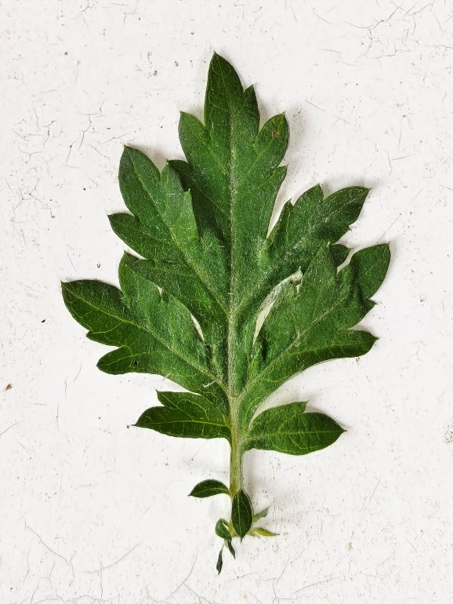
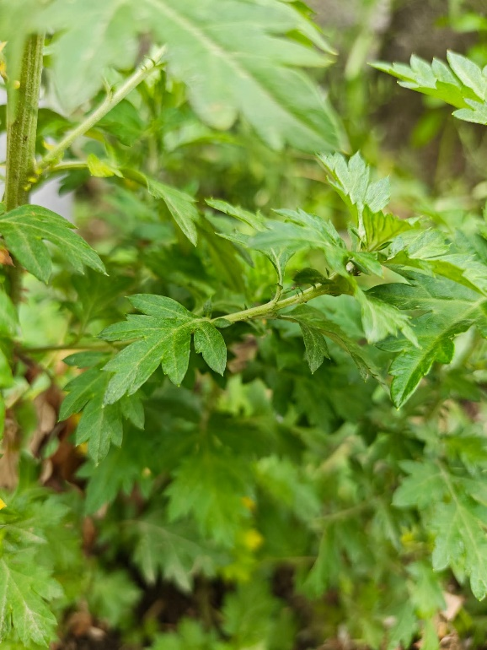
Damong Maria (Artemisia vulgaris), the aromatic herb used.

Figure 2
Drying of Damong Maria (Artemisia vulgaris) leaves, the preparation of the leaves before it is grinded/blended into a fine powder.
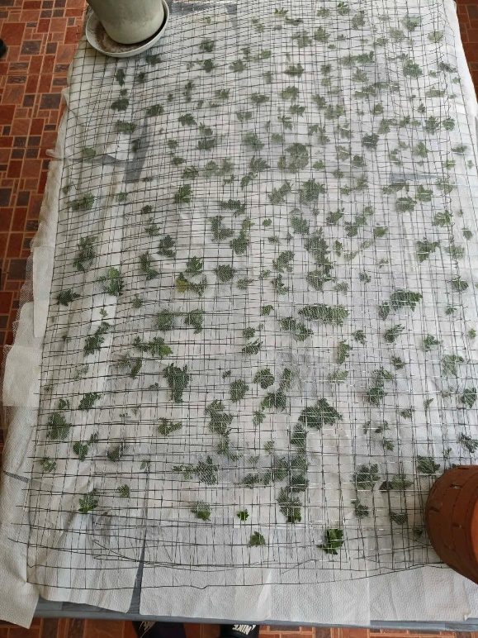

Figure 3
Maceration of Damong Maria (Artemisia vulgaris) leaves, the solution that became the extract after it is water bathed. It was macerated for 42 hours.
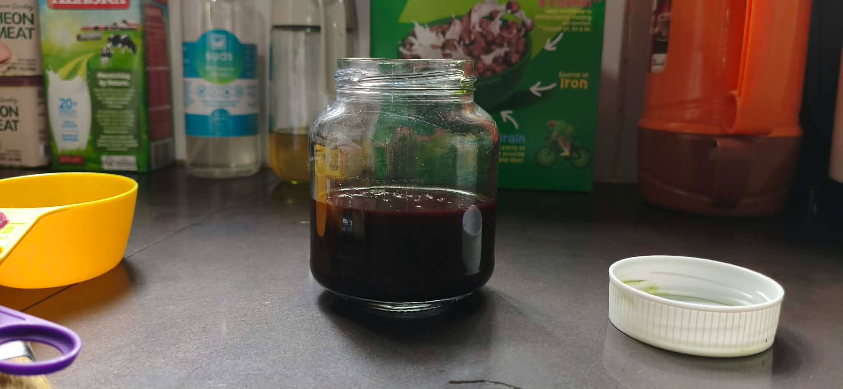

Figure 4
Making of corn syrup, the adhesive/base that the Damong Maria (Artemisia vulgaris) extract got added into.
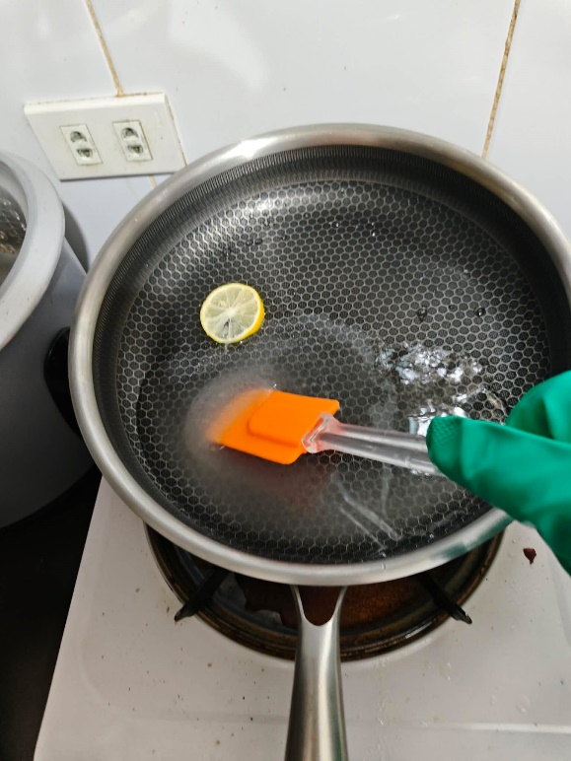

Figure 5
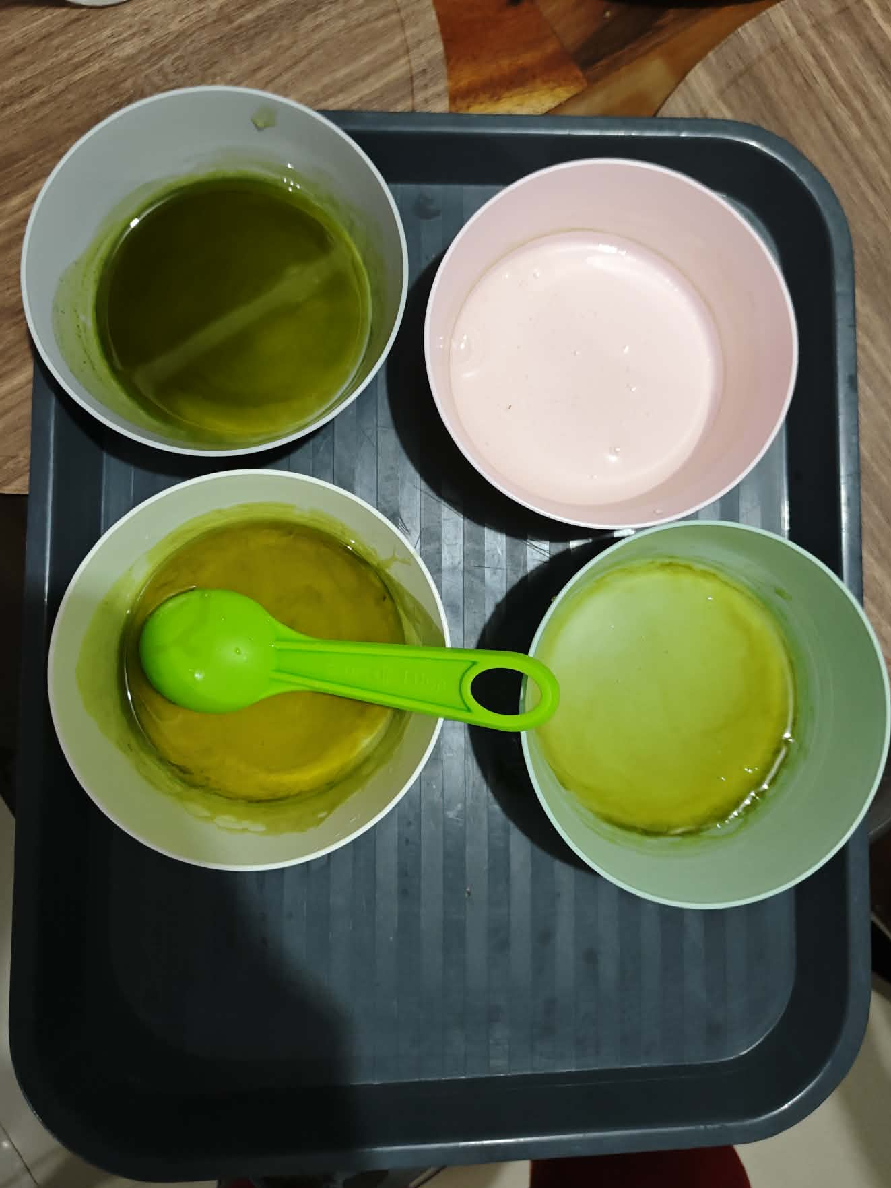
Mixing of Damong Maria (Artemisia vulgaris) leaf extracts, the adhesive/base mixed with the extract that will be used in the final product. Each bowl consisted of 2.5 tbsp of corn syrup.

Figure 6
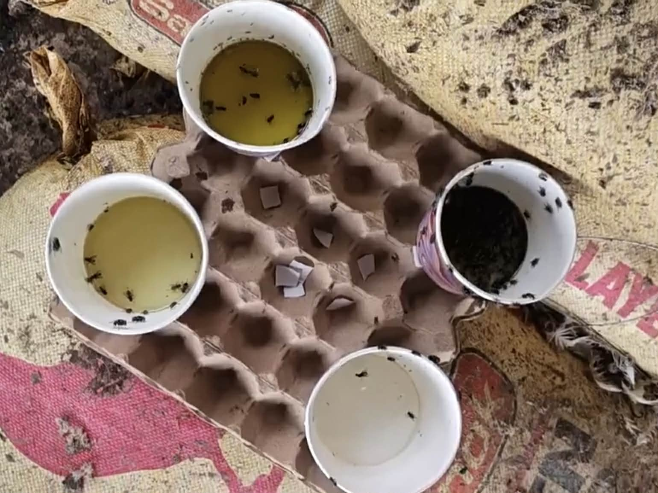
Field Testing of Damong Maria (Artemisia vulgaris) sticky flytraps. Field testing was conducted between 11 am - 5 pm. 4 variables were used and it was replicated 3 times. This is the picture of the replication which had 4 variables. The picture was took on 5 pm.

Figure 7
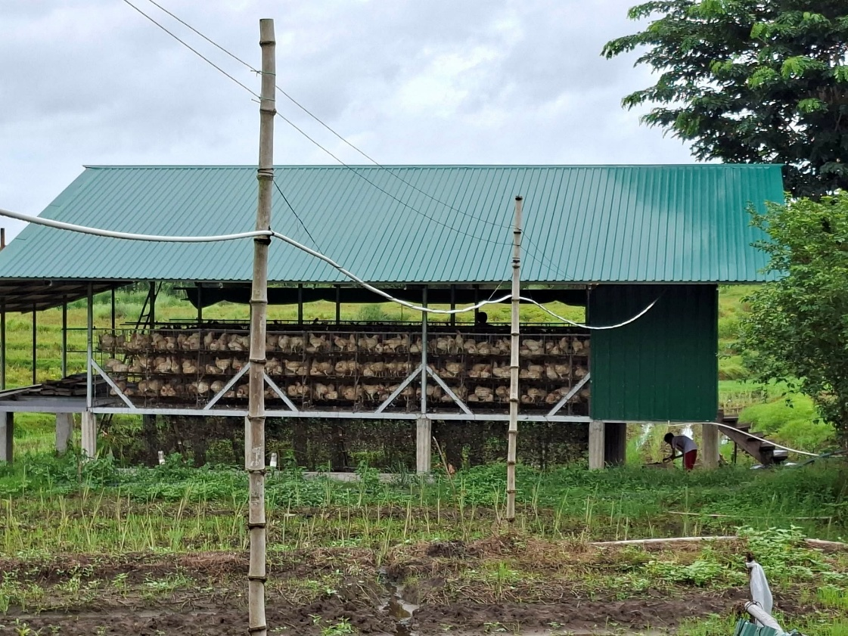
Poultry Farm in Magmarale, San Miguel, Bulacan. The place where the field testing of the final sticky flytrap was held.

Appendix
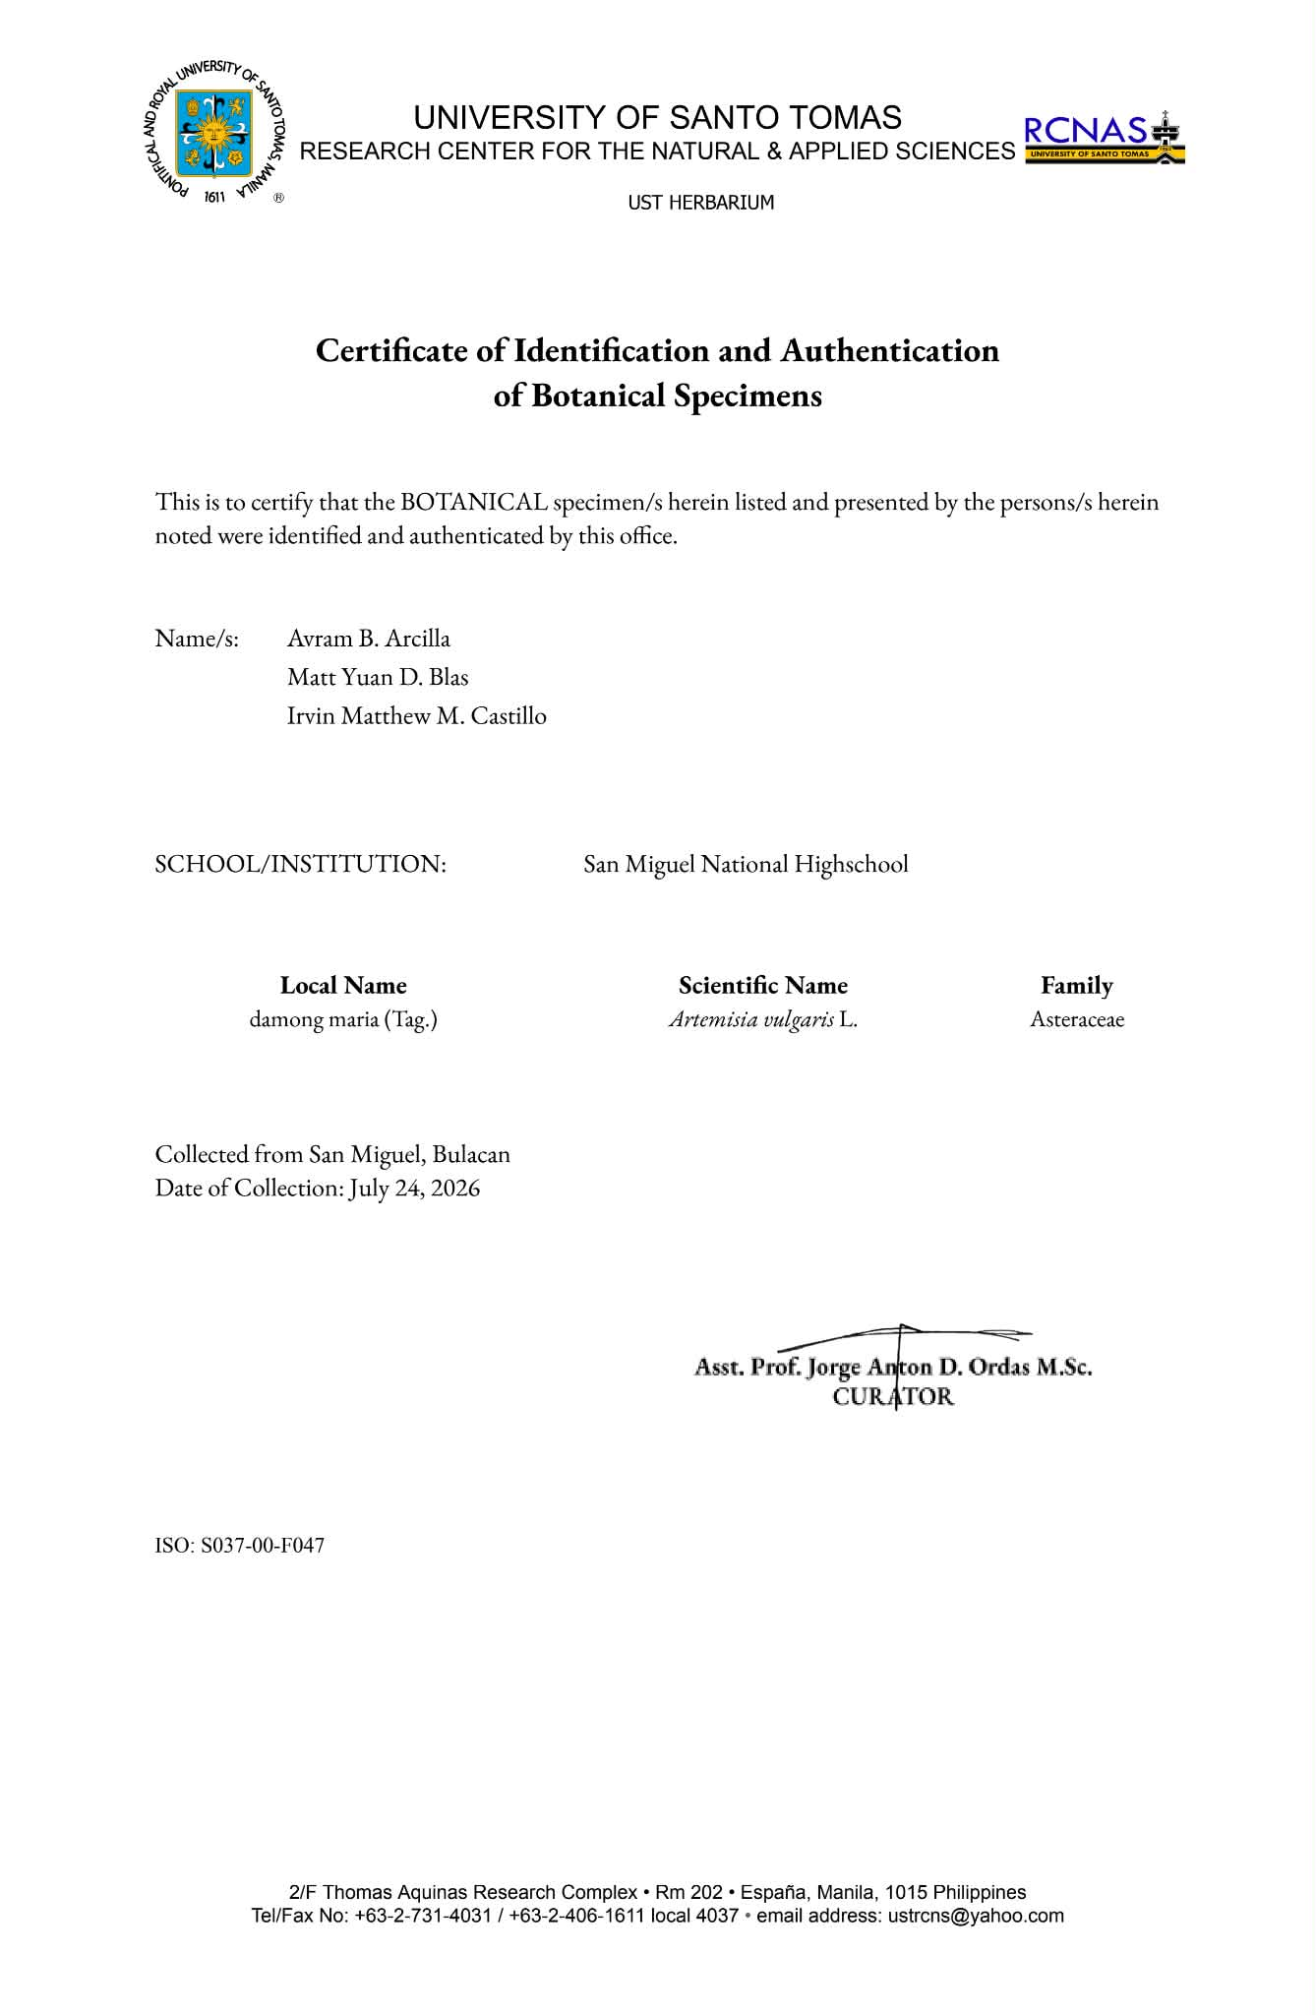
CERTIFICATION/LABORATORY RESULT

