The Effects of Childhood Trauma on Social Workers' Career Satisfaction Within Social Work Organizations and Public School Districts in Wisconsin
April 30, 2025
Word Count: 4,968

Abstract
Throughout America, social workers experience lower career satisfaction than almost any other field in America. This pattern of dissatisfaction is not only current but has been prominent since the early 2000s and has been steadily growing. Speculation suggests that although social workers' career dissatisfaction may be a result of exposure to violent and high-pressure workplace circumstances, it may also be a result of childhood trauma. Adverse childhood experiences such as abuse, neglect, and overall maltreatment result in cognitive trauma and almost always lead to unhappiness and dissatisfaction when untreated. In 2017, the National Library of Medicine published a study to examine the existing evidence based on the rates of childhood trauma in medical student populations (King et al., 2017). The findings speculated that students with a history of childhood trauma might preferentially apply to study medicine (King et al., 2017). Conjecture suggests that those who experience childhood maltreatment are more likely to enter helping careers such as medicine, healthcare, and, more notably, social work thus providing reasoning behind the speculation previously mentioned. Despite this, no previous studies have tested the correlation between social worker's career satisfaction and the severity of their childhood trauma. Therefore, this study investigates whether a significant correlation exists between childhood trauma severity and social worker career satisfaction. This report discusses the presence or absence of a correlation between the severity of childhood trauma and social workers' career satisfaction in social work organizations and public school districts in Wisconsin, as well as the magnitude of its effect. This explores the correlation between childhood trauma severity and social worker career satisfaction in Wisconsin. Pre-existing scales that measure the severity of childhood trauma (Adverse Childhood Experiences Scale) and career satisfaction (Job Satisfaction Scale) show a correlation or lack thereof between these two variables by comparing the scores of said tests and finding the correlational coefficient, or R-value. Participants were recruited through Wisconsin public school districts and social work organizations via email. Surveys containing the ACES and JSS assessments were distributed, and responses were analyzed using Pearson’s correlation coefficient to determine statistical significance. The findings of this study aim to provide insight into how early life experiences shape career trajectories and professional well-being, especially in emotionally demanding fields like social work. If a correlation is present between the severity of childhood trauma and social workers' career satisfaction then this study can provide possible solutions for social workers' career dissatisfaction if it presents as a result of childhood trauma. Findings from this study can inform trauma-informed workplace policies and mental health support programs, helping improve job satisfaction and retention in social work.

Childhood traumas, including abuse, neglect, and overall maltreatment, are kept at a distance from the media, stripping awareness of it and the traumas associated with it from American sociological norms. In 2009, the National Institute of Mental Health published a study that found that adults who had experienced any type of maltreatment in childhood were twice as likely as non-victims to be unemployed or dissatisfied with their work (NIMH, 2009). Similar research surrounding the long-term effects of childhood maltreatment has nearly identical findings.

Literature Review
Childhood trauma or even the simple presence of adverse childhood conditions affects the lives of victims, sometimes following people into adulthood regarding overall career choice and their cognitive health throughout their careers. Social workers in different areas display lower career satisfaction than other similar fields (NASW, 2020). In many cases, lower career satisfaction in the social work field is a result of the often violent circumstances of work in the field but an understudied and contributing factor to this is childhood experiences or maltreatment. Regardless of the source of this dissatisfaction, it is a frequently recognized issue; The Delaware Journal of Public Health published an article stating that social workers' burnout is a public health issue that must be addressed (Ratcliff, 2024). The issue that remains unremedied is the social worker's burnout and dissatisfaction as an association with childhood experiences like maltreatment. A foundational study of this research study is one done by researchers at the University of Toronto's Department of Psychiatry in 2012. This study aimed to determine how paramedics who possess childhood trauma respond to critical incidents and the symptoms that occur as a result of these incidents. In this study, six hundred and thirty-five paramedics were surveyed regarding their childhood experiences of physical, sexual, or emotional abuse as well as an index of critical incidents from the past and the corresponding acute stress responses to said events (Maunder et al., 2012). This study found that paramedics who reported childhood maltreatment more frequently experienced signs of acute stress immediately following the index critical incident (Maunder et al., 2012). This study exemplifies the mental health impacts of childhood or early life traumas on cognitive well-being during a victim's career and in later years of life. This study provides a gateway to various others that similarly reveal that those who experienced maltreatment in their childhood years (0-17) are considerably more likely to enter helping careers such as medical careers and careers within the social work field. One example of this is the story of Mallorie Moore. In 2021, the South Carolina College of Social Work published an article about a social work student named Mallorie Moore. Moore stated that most of her “motivation for wanting to study social work came from her “childhood and not having the best experiences with the child welfare system” She also stated, “I also wanted to be the person that I would have wanted there for me when I was their age” (Woodley, 2021). Despite this being a frequent reason for individuals to enter the social work field, people who have entered these ‘helping fields’ most prominently social work, have reported lower career satisfaction than other groups of people in helping careers (Frinter et al., 2022). Within these helping careers like pediatrics and psychiatry, the discipline that is more often ignored in regard to remedying career dissatisfaction is the social work field. The social work field can range in the sense of work environment, skills, and even training but what goes unnoticed and unprioritized is the career dissatisfaction of American social workers. In 1998, over twenty years ago, Oxford Academic scholars found that social workers may experience lower career satisfaction as a result of exposure to violence and harsh workplace conditions. These conditions create acute stress, and allow for this dissatisfaction to remain at a steady increase (Balloch et al., 2024). More recently, just five years ago in 2020, The National Association of Social Workers found that in Alexandria, Virginia, nearly ten percent of social workers reported being dissatisfied with their positions, and these findings were later found to correspond similarly across all of America (NASW, 2020). Both Oxford Academic (1998) and NASW (2020) highlight high dissatisfaction rates among social workers, though for different reasons—Oxford attributes it to workplace violence, while NASW highlights broader burnout factors. Regardless of the different potential factors at play, these studies suggest that dissatisfaction is a persistent issue, thus highlighting the need to examine how past trauma might contribute to this dissatisfaction, which this study will address. This research still leaves the correlation between childhood trauma and the career satisfaction of social workers undetermined.

Despite this unanswered question, The National Library of Medicine found that in any career, adverse childhood conditions such as abuse or neglect may cause decreased feelings of meaningfulness and create less workplace motivation (Icekson et al., 2024). Combining the factors of a violent and stressful career with the possibility of previous childhood traumas, social workers struggle to endure while continuing to go unnoticed and unhindered, social workers are given further grounds to enter a state of dissatisfaction. More recently, researchers have noticed that all categories of social work experience these low levels of satisfaction. The causes of this lowered career satisfaction among social workers in The United States, seem to vary from burnout to the presence of high stress levels but still, childhood/ past experiences have not been taken into account (Ratcliff, 2024). The effects of social workers' career dissatisfaction in the United States can be traced back to several seemingly unrelated issues. Research and studies completed previously look into social worker’s career satisfaction, their childhood traumas, and even the reason they choose to enter the social work field. Which still leaves the relationship of two of these listed variables undetermined. That correlation being that between social workers' career satisfaction and the severity of their childhood trauma undiscovered creating a gap in research. The severity of childhood trauma is most frequently measured using quantifiable scales like the ACES Assessment when addressing mental health rather than to inform on a correlation between this trauma, and the career satisfaction of individuals within a specific field. This leads to career satisfaction needing to be quantified using nine specific facets that must be evaluated, this is done in the JSS assessment. Despite existing research on career satisfaction and childhood trauma separately, no study directly examines the correlation between childhood trauma severity and social worker career satisfaction. This study seeks to fill that gap by using the ACES and JSS assessments to quantify this relationship. Childhood experiences, and childhood trauma more specifically, play a direct role in career choice, but how do these adverse childhood experiences affect career satisfaction among social workers specifically? Using pre-existing scales to quantify both addressed variables creates a gap in preexisting research. This leads to the speculation that childhood trauma does contribute to social workers' career satisfaction, or the lack thereof, in The United States and more specifically, the Wisconsin state area.

Research Question and Hypothesis
This study examines the relationship between the severity of childhood trauma and career satisfaction among social workers in Wisconsin and asks the question, to what extent does childhood trauma severity impact social worker career satisfaction in Wisconsin? This question brings the hypothesis that social workers between the ages of twenty-four and sixty-six will experience lower career satisfaction in their field if they experience more severe childhood trauma/ maltreatment. This study investigates whether higher childhood trauma exposure leads to lower career satisfaction among social workers, using the ACES and JSS Assessments to quantify this relationship.

Methods
Method Declaration
Given the AP Research two-trimester timeline, a longitudinal study is not feasible so this study was done using a cross-sectional method of a survey. This study is a mixed-method study, meaning it collected both qualitative and quantitative data. The prerequisite data collected is demographic data such as birth-assigned gender, race, age, years of experience in the field, job title, and employer. This does not qualify as qualitative or quantitative data and is in a separate section of the survey titled Demographic Questions. The qualitative data collected includes questions to individuals about their career path and how they feel that their childhood experiences played a role in their education and career path. This is another section of the survey titled Personal Questions. These also ask about experiences and motivation during the foundational years of career choice, such as high school, and early college, to draw conclusions regarding specific groups of people and provide further context within the background of each participant's lived experience. This data is collected to discover if demographic data can provide insights into patterns that may exist between this data and the levels of satisfaction collected. The quantitative data collected is scored using the Adverse Childhood Experiences Scale (ACES) and the Job Satisfaction Survey (JSS), which are measures of the severity of childhood trauma variables and career satisfaction variables. Collecting demographic and qualitative data that is not included in the preexisting assessments (ACES & JSS) does not dilute the validity of the quantitative data collected. This method may prove or disprove a correlation between the severity of childhood trauma using the ACES scores and social workers' career satisfaction using the JSS scores. If the hypothesis is accurate, the data will show that high ACES scores correlate with low JSS scores.

Participants
Participants ranged from school social workers to clinical social workers, but all participants were based in Wisconsin. School social workers were reached through a local suburban High School’s social worker, and clinical social workers were primarily based at Davita Kidney Dialysis, Empathia Mental Health Services, and Aurora Healthcare, to name a few. Participants were all between the ages of twenty-four and sixty-six. The base starting age is twenty-four because a standard social work degree requires four years of schooling, making participants twenty-two years old after receiving their degree if they follow a standard post-high school path. The additional two years, making the starting age requirement, are in place to ensure that participants have experience in the workforce. American social workers having at least a year of work experience makes them qualified in the field enough to respond to questions regarding their satisfaction in their position. The age cutoff, sixty-six, is in place because that is the average retirement age for social workers in the United States, and will help keep the cohort of participants constant in the fact that they are all currently employed in their chosen form of social work (NASI, 2024). Using this group of participants proves or disproves the hypothesis of this study because they are the group applicable to the research question parameters: American social workers based in Wisconsin between the ages of twenty-four and sixty-six. Within these parameters, this study obtained 21 participants. Within the data collected from these participants, 95% of participants identified as white/ caucasian/ European, and 90% of participants were women. This was expected in consideration of the fact that over 85% of American social workers are female (Tuffield, 2017). A study published by West Texas A&M University also reveals that nearly 85% of licensed social workers are white or white presenting (Loya). These demographic factors follow preexisting trends and do not compromise the validity of the study results, instead hinting at proposed accuracy as the cohort follows larger-scale trends and has an accurate representation of said trends.

Protocol Design
In order to accurately measure the severity of childhood trauma and the career satisfaction of social workers in Wisconsin, both the severity of childhood trauma and social workers' career satisfaction must be measured. On the childhood trauma front of the study, circumstance, and response to the trauma must be evaluated and then quantified to assign a number score to each participant to represent the severity of their childhood trauma. The ACES assessment began development in 1995 when the CDC-Kaiser Permanente began a study intended to discover if certain adverse childhood experiences are risk factors for the leading causes of illness, death, and poor quality of life (PCA, 2024). Since 1997, at the conclusion of this study, the ACES assessment has proven to yield valid and reliable results and effectively help diagnose childhood trauma. Vincent J. Felitti and Robert Anda, who performed this study, created the ACES assessment upon discovering the correlation between adverse childhood experiences and adulthood health complications. The ACES assessment contains only ten questions, and each is answered with either A, B, Both, Non Applicable, Yes, or No depending on the situation/ circumstance of life described in the question. When the survey is complete, one point is allocated to each question answered A, B, Both, or Yes. A score of 0 represents no presence of childhood trauma, a score of 2-4 represents moderate childhood trauma and a score of 5 or higher represents severe childhood trauma; the higher the score, the more adverse the childhood experiences were.

In terms of career satisfaction, nine specific facets were evaluated. The nine facets include Pay, Promotion, Supervision, Fringe Benefits, Contingent Rewards (performance-based rewards), Operating Procedures (required rules and procedures), Coworkers, Nature of Work, and Communication (Spector, 2022). To evaluate these facets, another preexisting assessment was used called the Job Satisfaction Survey, which will be referred to in the future as the JSS. The JSS assessment was finalized and began use in 1985 and has been effective in bettering workplace environments across America since then. The JSS is now used internationally and most notably in corporate America. The JSS contains 36 questions; each question makes a statement regarding the circumstances of the participant's job and presents a six-point Likert scale ranging from Strongly Disagree to Strongly Agree. When the survey was complete, the scale responses were added. One through six points are assigned to the strongly agree or strongly disagree side of the scale depending on the circumstances of the question. If the score is between 36 and 108, the individual is dissatisfied. If the score is between 108 and 144, the individual is moderately satisfied. If the score is between 144 and 216, the individual is satisfied. The higher the score, the more satisfied the individual is with their career.

Alongside the two measurable variables (severity of childhood trauma and career satisfaction), other content is relevant. The survey also asks for the demographic data of each participant, such as age, race, birth-assigned gender, years of experience in the field, job title, and employer. This demographic data enables patterns within smaller groups to become visible within the entire experimental group of social workers in Wisconsin. It is because of the combination of qualitative and quantitative data collection that this study is a mixed-method study. The scoring from the JSS and ACES assessments act as quantitative data, and the demographic questions used to draw more concise correlations within the experimental group act as guidelines to help interpret these scores. In addition to this, demographic data may provide other insights about satisfaction in post-hoc analysis. Alongside the quantitative data, additional data collected includes questions about participants' career paths and how they feel that their childhood experiences played a role in their education and career path, qualitative data. This data was collected to discover if the participants were aware of the patterns that may be discovered using the quantitative data collected. Collecting demographic and qualitative data that is not included in the preexisting assessments does not compromise the validity of the data collected.

The given survey was titled Childhood Experiences and Social Work - A Research Study. The survey was created on Google Forms and released to contacts using Gmail. The Gmail sent was identical for every participant transparently discussed the purpose of the study and contained a link to the Google form survey. The data collected was stored in Google Forms and in a Google sheet under an account that is password-secured. Data collection began on December 12th, 2024, and ended on January 16th, 2025, providing 5 weeks for data collection. Participants may choose to remain anonymous and receive a copy of the final report or not. After the form is completed, a screen appears telling participants that the form was created inside the Mequon-Thiensville School District. The word framing of the questions was designed to be straightforward and used simple vocabulary for optimal understanding for each participant.

The survey was split into five sections. The first section was unnamed and asked participants to indicate their consent by asking first if they consented to their responses and data being used to draw the proposed correlation of the study. Each participant indicated their consent by pressing Yes or No. To solidify and further indicate their consent, participants were asked to type their birth-assigned first and last name or digitally sign the ‘consent form’. Participants were then asked if they would like their responses to be kept anonymous; if not, they may indicate their preferred name. The second section of the survey is titled Demographic Questions and asks about age, birth-assigned gender, race, years in the field, and job title. The third section is titled Career Satisfaction Questions and contains the JSS questions. The fourth section is titled Personal Questions and asks questions regarding motivation, high school experiences, childhood experiences, career choice, and why they chose to enter the social work field. This section aims to provide further context regarding their scores in the quantifiable areas of the survey. The fifth and final section of the survey is titled Childhood Experiences Questions, and this section contains the ACES questions. At the end of the survey participants were asked if they would like to be informed of the results of this study and those who answered yes may provide their email or phone number.

Results
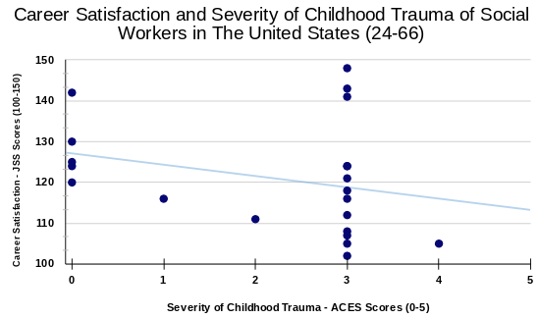

The scatterplot above represents the data collected in the survey, each dot on the scatterplot represents one participant. The X-axis represents the severity of the childhood trauma variable which was measured using the ACES assessment. The ACES scores are represented on the X-axis. Only ACES scores ranging from 0 to 5 are represented in the scatter plot because that is the interval in which all participants answered. The Y axis represents the social worker's career satisfaction which was measured using the JSS assessment. Only JSS scores between 100 and 150 are represented in the scatter plot because that is the interval in which all participants answered.

Analysis
The 95% confidence intervals of the collected data were 12.03-25.9 on the X axis (representing ACES scores in relation to the hypothesis prediction) and 124.8-135.5 on the Y axis (representing the JSS scores). This confirms that the predicted intervals in the hypothesis are validated by the values collected in the data collected via the survey.

The r-value or correlation coefficient of this data sample was determined to be 0.78. A correlation coefficient indicates the strength of a relationship between two variables. A R-value of 0 demonstrates a weak relationship and a R-value of 1 demonstrates a strong relationship. The r-value of the data sample in this study represents a moderately strong relationship between the severity of childhood trauma and the career satisfaction of social workers being 0.78/1. The data collected shows a negative correlation between the severity of childhood trauma and social workers' career satisfaction in Wisconsin. This means that the more severe each participant's childhood trauma was, the less satisfied they were with their career. The correlation predicted in the hypothesis was affirmed by the correlation discovered in the collected data.

Discussion
Implications
This study suggests that individuals who experienced more severe childhood trauma tend to have lower career satisfaction in social work. This correlation may indicate that unresolved childhood trauma affects professional fulfillment, potentially leading to burnout or dissatisfaction. The findings provide insight into how early life experiences shape career trajectories and professional well-being, especially in emotionally demanding fields like social work. It is important to inform people within the social work field and inside general audiences of these patterns and this specific correlation because of the effects of their presence. These effects can range from general dissatisfaction and mental anguish to unemployment (NIMH, 2009).

Potential Solutions
In an article published by Michelle Ratcliff, various forms of self-care and implementations that social workers and their loved ones can adopt are suggested to treat this burnout because the consequences of burnout can be harmful to workers, the people they service, their families, and social workers’ careers (Ratcliff, 2024). American social workers are on the search for solutions and implementations to their burnout, anxiety, and overall discomfort in regard to their careers but knowing the possible causes of it can provide more trauma-specific solutions. Some potential solutions to the dissatisfaction of social workers as a result of childhood trauma and childhood experiences have been considered. One solution that could be implemented is trauma-informed training. Trauma-informed training would lead to social work programs and workplaces implementing trauma-informed practices to better support employees who have experienced childhood trauma. Some of these practices include support, compassion, and using the safe space program to create an open work environment. A second possible solution to this childhood trauma-caused career dissatisfaction is mental health support. Organizations can offer therapy, counseling, and resilience training to help social workers manage past trauma and prevent burnout. A third possible solution is mentorship programs. Establishing mentorship opportunities with experienced professionals may help those with trauma backgrounds develop coping strategies and workplace satisfaction. A final possible solution to this dissatisfaction is implementing new workplace policies. Employers could create supportive work environments that acknowledge the emotional toll of the profession and provide resources for self-care and emotional well-being. There are many possible solutions to improve the career satisfaction of social workers who have experienced more severe childhood trauma. Many of these implementations require social work programs and social work employers to be aware of this correlation which is an audience that this study aims to inform. In order for social workers to obtain the resources they need to experience higher career satisfaction, employers of large-scale corporations, such as the National Association of Social Workers, need to be aware of the correlation between social worker's career satisfaction and the severity of their childhood trauma.

Positive Impacts
The results of this study and the negative correlation discovered make the issue at hand seem overwhelming and even pessimistic, but help in drawing the conclusion that trauma is a leading factor in the present dissatisfaction in social work. This study does suggest possible solutions to social workers' dissatisfaction in Wisconsin, but the presence of this dissatisfaction insinuates a less promising future for those in the social work field. However, it is important to note some positive impacts of this study for many groups of people. First and foremost this study addresses awareness and prevention This study brings awareness to the long-term effects of childhood trauma and encourages interventions to improve career satisfaction amongst not just social workers but anyone who has experienced childhood maltreatment and trauma. By addressing the needs of social workers with trauma histories, organizations may reduce turnover rates and improve overall career satisfaction This will keep social workers already employed, employed for longer, and more satisfied with their careers. This study also addresses and validates the idea of personal growth and healing for victims of childhood trauma in the social work field. Recognizing the impact of childhood trauma on career satisfaction can empower social workers to seek support and engage in personal development. Lastly, this study can enable those who are informed of this correlation to provide and create stronger support systems. Findings from this research can contribute to improved workplace policies that promote well-being and resilience in the social work profession.

Limitations and Future Studies
Limitations
When considering the results of this study and the implications and positive impacts it is important to address the limitations of this study before further studying this topic. The least restrictive limitation of this study was the demographic groups of the participants. The intended experimental group aimed to collect data from Wisconsin area social workers between the ages of twenty-four and sixty-six. Not white, female, Wisconsin area social workers between the ages of twenty-four and sixty-six. This minorly compromises the validity of the data and the affirmation of the hypothesis but does not invalidate the correlation found between the severity of childhood trauma and career satisfaction.

An additional limitation of this study was the experimental group size. To better prove a strong correlation between the severity of childhood trauma and social workers' career satisfaction, an experimental group of between 30 and 50 people would better prove a strong correlation than an experimental group of 21, which is what was collected in this study (NIH, 2024). A study published by the National Library of Medicine examined how many participants are necessary to “properly power an experiment.” This supports the idea that 21 participants are not an ideal experimental group size to prove a strong correlation (NIH, 2024). Future research should emphasize the recruiting process to obtain a larger participant pool.

The second but less prominent limitation of this study is the method type. What would have provided more accurate results would be a longitudinal study. Longitudinal studies employ continuous or repeated measures to follow particular individuals over prolonged periods—often years or decades. The timeline given in the AP Research course does not allow for a longitudinal study. A study published by the National Library of Medicine in 2015, explains that according to the research done by the Department of Thoracic Surgery at Papworth Hospital in Cambridge, UK, a longitudinal study is more effective in proving correlations between two variables with people acting as participants/subjects (Caruana et al., 2015). The primary limitations of this study are within the experimental group and the method type but the data sample has proven to be significantly significant regardless.

Conclusion
The results of this study help to inform on the correlation between trauma and satisfaction by providing data that suggests the correlation exists by quantifying each variable using pre-existing assessments. The data sample shows that there is a negative correlation between the two measured variables, the scores on each assessment, meaning that as one increases the other decreases. It is important to note that despite the correlation discovered seeming to have negative undertones it is important to note satisfaction patterns within the field regardless of the result. It is necessary to understand these patterns to implement solutions to issues at hand, such as the career dissatisfaction that may be a result of childhood trauma among social workers in Wisconsin. Social workers who completed the survey used for data collection in this study were asked why they chose to enter the field of social work. In one particular response a participant said that they needed change in their childhood and social workers offered it to them and that they “wanted to be the change for others”. This study aims to solidify and make the changes needed within the social work field to increase workplace and career satisfaction of social workers in Wisconsin who have experienced childhood trauma and who experience career dissatisfaction as a result.

Bibliography
"ABOUT CHILDHOOD TRAUMA." The National Child Traumatic Stress Network, NCTSN. Accessed 9 Oct. 2024.
"ACE Study." Positive Childhood Alliance of North Carolina, www.preventchildabusenc.org/resource-hub/aces-study/#:~:text=The%20Adverse%20Childhood%20Experiences%20(ACE,life%20in%20the%20United%20States. Accessed 18 Nov. 2024.
Balloch, Susan, et al. "Working in the Social Services: Job Satisfaction, Stress and Violence." Oxford Academic, 1 June 1998. Accessed 31 Oct. 2024.
Bester, Monica. "Transmuting Childhood Trauma: A Case Study exploring the impact of childhood trauma on the career choice and teaching experiences of Special Education Teachers." University of Memphis Digital Commons, U of Memphis, May 2024.
Bryce, India, et al. "A Systematic Literature Review of the Career Choice of Helping Professionals Who Have Experienced Cumulative Harm as a Result of Adverse Childhood Experiences." Pubmed, National Library of Medicine, 18 May 2021. Accessed 23 Sept. 2024.
Brysbaert, Marc. "How Many Participants Do We Have to Include in Properly Powered Experiments? A Tutorial of Power Analysis with Reference Tables." National Library of Medicine, PubMed, 19 July 2019. Accessed 5 Feb. 2025.
Caruana, Edward Joseph, et al. "Longitudinal studies." National Library of Medicine, 7 Nov. 2015. Accessed 27 Feb. 2025.
Curtis, Lesley, et al. "The Expected Working Life of a Social Worker." Research Gate, 1 July 2010, www.researchgate.net/publication/233741491_The_Expected_Working_Life_of_a_Social_Worker#:~:text=In%20fact%2C%20social%20workers%20stay,et%20al.%2C%202010)%20. Accessed 11 Nov. 2024.
Frinter, Mary Pat, et al. "Changes in Work Characteristics and Pediatrician Satisfaction: 2012-2020." PubMed, National Library of Medicine, 1 July 2022. Accessed 30 Oct. 2024.
"History of Childhood Maltreatment Linked to Higher Rates of Unemployment, Poverty." National Institute of Mental Health, NIMH, 15 Oct. 2009.
Icekson, Tamar, et al. "Childhood Maltreatment and Adult Work Absenteeism: Work Meaningfulness as a Double-Edged Sword." PubMed Central, National Library of Medicine, Apr. 2024. Accessed 31 Oct. 2024.
---. "National Library of Medicine" ["Childhood Maltreatment and Adult Work Absenteeism: Work Meaningfulness as a Double-Edged Sword"]. PubMed Central, National Library of Medicine, 21 Apr. 2024.
Jacob, Theodore, and Sheri Johnson. "PARENTING INFLUENCES ON THE DEVELOPMENT OF ALCOHOL ABUSE AND DEPENDENCE." Alcohol Health & Research World, 3 Nov. 1997. SIRS Issues Researcher. Accessed 9 Sept. 2024.
"Job in General Scale." APA PsycNet. Accessed 4 Oct. 2024.
King, Eimear, et al. "Prevalence rates of childhood trauma in medical students: a systematic review." Pubmed, National Library of Medicine, 12 Sept. 2017. Accessed 23 Sept. 2024.
Koçak, Orhan, et al. "The Associations between Childhood Experiences and Occupational Choice Capability, and the Mediation of Societal Gender Roles." National Library of Medicine, Pub Med Central, 10 June 2022. Accessed 9 Sept. 2024.
Kristof, Nicholas. "We Americans Neglect Our Children." SIRS Issues Researcher. SIRS Issues Researcher. Accessed 9 Sept. 2024.
Loya, Melody. "Racial Attitudes in White Social Workers: Implications for Culturally Sensitive Practice." wtam.edu. Accessed 25 Feb. 2025.
MacIntire, Mae M. "PREDICTORS OF THE RELATIONSHIP BETWEEN CHILDHOOD MALTREATMENT AND CAREER DECISION SELF-EFFICACY AMONG UNDERGRADUATE STUDENTS." University of North Texas Digital Library, U of North Texas Digital Library, Aug. 2015.
Maunder, Robert G., et al. "Symptoms and responses to critical incidents in paramedics who have experienced childhood abuse and neglect." PubMed Central, National Library of Medicine, 29 Mar. 2012. Accessed 20 Sept. 2024.
Mustillo, Sarah A., et al. "Children of Misfortune: Early Adversity and Cumulative Inequality in Perceived Life Trajectories." American Journal of Sociology, JSTOR.
"New Report Provides Insights into New Social Workers' Demographics, Income, and Job Satisfaction." National Association of Social Workers, NASW, 11 Dec. 2020. Accessed 9 Oct. 2024.
Oláh, Barnabás, et al. "Validity and Reliability of the 10-Item Adverse Childhood Experiences Questionnaire (ACE-10) among Adolescents in the Child Welfare System." National Library of Medicine, PubMed, 17 Nov. 2023. Accessed 20 Nov. 2024.
Pottle, Zachary. "The Top 10 Jobs With The Highest Rates Of Drug Abuse." Addiction Center, 5 Aug. 2024, www.addictioncenter.com/community/jobs-highest-addiction-rates/#:~:text=1.,alcohol%20abuse%20of%20any%20profession. Accessed 9 Sept. 2024.
Ratcliff, Michelle. "Social Workers, Burnout, and Self-Care: A Public Health Issue." PubMed - Delaware Journal of Public Health, National Library of Medicine, Mar. 2024. Accessed 1 Nov. 2024.
Spector, Paul. "Job Satisfaction Survey." Paul Spector, 2022, paulspector.com/assessments/pauls-no-cost-assessments/job-satisfaction-survey-jss/#:~:text=The%20nine%20facets%20are%20Pay,Nature%20of%20Work%2C%20and%20Communication. Accessed 18 Nov. 2024.
Straussner, Shulamith Lala Ashenberg, and Evan Senreich. "Productive Aging in the Social Work Profession: A Comparison of Licensed Workers 60 Years and Older with Their Younger Counterparts." PubMed Central, National Library of Medicine, 28 Jan. 2020. Accessed 9 Oct. 2024.
Tuffield, Natalie. "It's Called Social Work, Not Women's Work." Youth Today, 13 Feb. 2017, youthtoday.org/2017/02/its-called-social-work-not-womens-work/#:~:text=Nearly%2085%20percent%20of%20social,graduate%20degrees%20in%20the%20field. Accessed 25 Feb. 2025.
"What is the Social Security Retirement Age?" National Academy of Social Insurance. Accessed 11 Nov. 2024.
Woodley, Chris. "Childhood Trauma Motivates One MSW Student to Pursue a Social Work Career." College of Social Work, U of South Carolina, 28 Apr. 2021. Accessed 23 Sept. 2024.

Appendix A
Survey

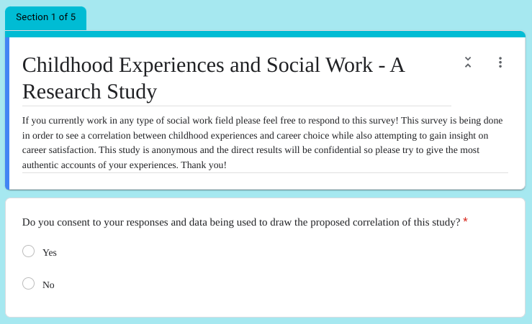
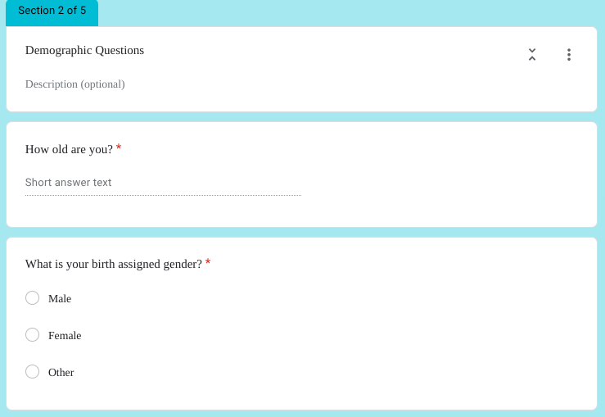
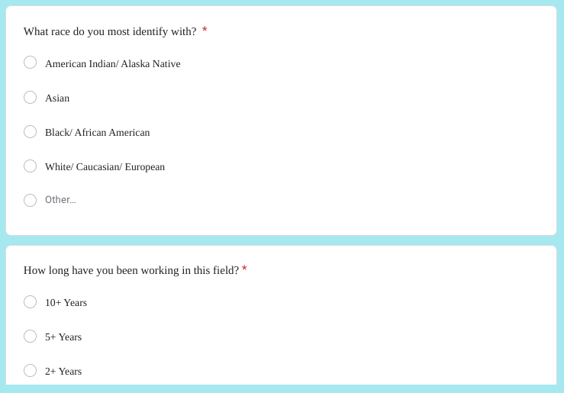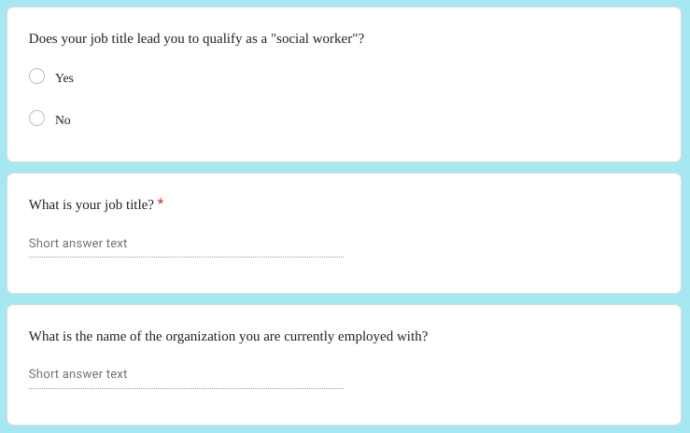

JOB SATISFACTION SURVEY
Paul E. Spector
Department of Psychology
University of South Florida
Copyright Paul E. Spector 1994, All rights reserved.
 | PLEASE CIRCLE THE ONE NUMBER FOR EACH QUESTION THAT COMES CLOSEST TO REFLECTING YOUR OPINION  ABOUT IT. | Disagree very much  Disagree moderately  Disagree slightly  Agree slightly  Agree moderately  Agree very much
1 | I feel I am being paid a fair amount for the work I do. | 1 2 3 4 5 6
2 | There is really too little chance for promotion on my job. | 1 2 3 4 5 6
3 | My supervisor is quite competent in doing his/her job. | 1 2 3 4 5 6
4 | I am not satisfied with the benefits I receive. | 1 2 3 4 5 6
5 | When I do a good job, I receive the recognition for it that I should receive. | 1 2 3 4 5 6
6 | Many of our rules and procedures make doing a good job difficult. | 1 2 3 4 5 6
7 | I like the people I work with. | 1 2 3 4 5 6
8 | I sometimes feel my job is meaningless. | 1 2 3 4 5 6
9 | Communications seem good within this organization. | 1 2 3 4 5 6
10 | Raises are too few and far between. | 1 2 3 4 5 6
11 | Those who do well on the job stand a fair chance of being promoted. | 1 2 3 4 5 6
12 | My supervisor is unfair to me. | 1 2 3 4 5 6
13 | The benefits we receive are as good as most other organizations offer. | 1 2 3 4 5 6
14 | I do not feel that the work I do is appreciated. | 1 2 3 4 5 6
15 | My efforts to do a good job are seldom blocked by red tape. | 1 2 3 4 5 6
16 | I find I have to work harder at my job because of the incompetence of people I work with. | 1 2 3 4 5 6
17 | I like doing the things I do at work. | 1 2 3 4 5 6
18 | The goals of this organization are not clear to me. | 1 2 3 4 5 6

 | PLEASE CIRCLE THE ONE NUMBER FOR EACH QUESTION THAT COMES CLOSEST TO REFLECTING YOUR OPINION  ABOUT IT.  Copyright Paul E. Spector 1994, All rights reserved. | Disagree very much  Disagree moderately  Disagree slightly  Agree slightly  Agree moderately  Agree very much
19 | I feel unappreciated by the organization when I think about what they pay me. | 1 2 3 4 5 6
20 | People get ahead as fast here as they do in other places. | 1 2 3 4 5 6
21 | My supervisor shows too little interest in the feelings of subordinates. | 1 2 3 4 5 6
22 | The benefit package we have is equitable. | 1 2 3 4 5 6
23 | There are few rewards for those who work here. | 1 2 3 4 5 6
24 | I have too much to do at work. | 1 2 3 4 5 6
25 | I enjoy my coworkers. | 1 2 3 4 5 6
26 | I often feel that I do not know what is going on with the organization. | 1 2 3 4 5 6
27 | I feel a sense of pride in doing my job. | 1 2 3 4 5 6
28 | I feel satisfied with my chances for salary increases. | 1 2 3 4 5 6
29 | There are benefits we do not have which we should have. | 1 2 3 4 5 6
30 | I like my supervisor. | 1 2 3 4 5 6
31 | I have too much paperwork. | 1 2 3 4 5 6
32 | I don't feel my efforts are rewarded the way they should be. | 1 2 3 4 5 6
33 | I am satisfied with my chances for promotion. | 1 2 3 4 5 6
34 | There is too much bickering and fighting at work. | 1 2 3 4 5 6
35 | My job is enjoyable. | 1 2 3 4 5 6
36 | Work assignments are not fully explained. | 1 2 3 4 5 6

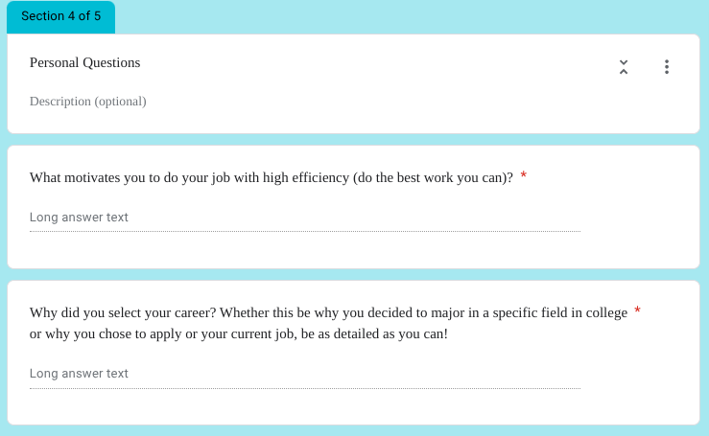

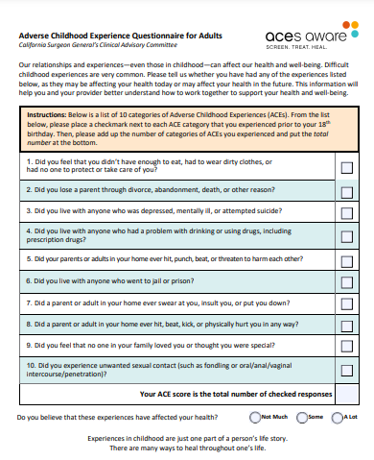
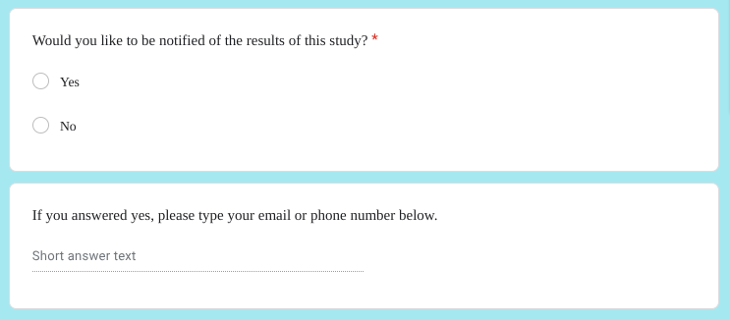

Appendix B
Participant Contact
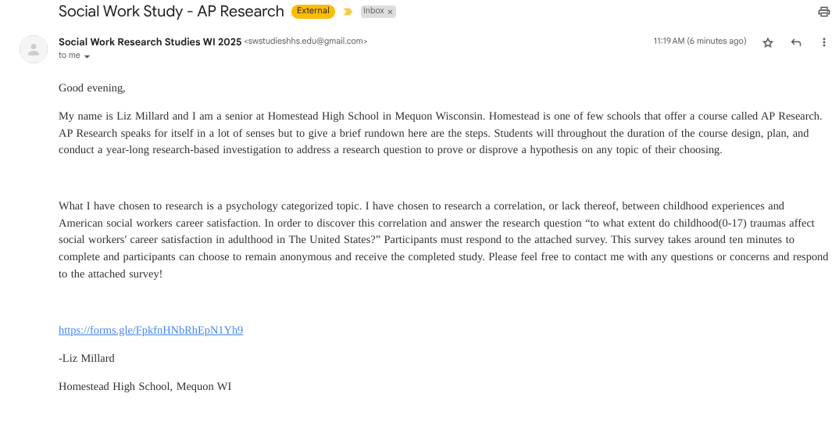

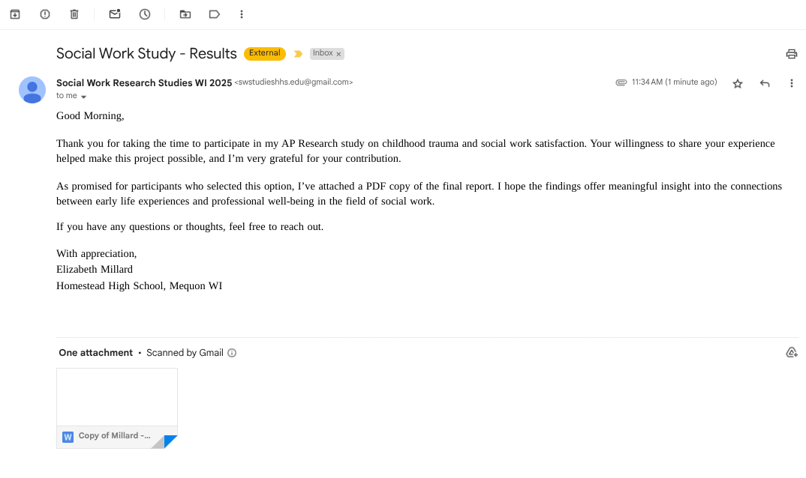

Appendix C
Results

ACES Scores | JSS Scores
0 | 120
0 | 130
2 | 111
1 | 116
3 | 107
0 | 124
0 | 142
4 | 105
0 | 125
3 | 108
3 | 112
3 | 118
3 | 124
3 | 141
3 | 124
3 | 105
3 | 116
3 | 148
3 | 121
3 | 143
3 | 102

