Cross-Model Agreement as an Escalation Signal for LLM Cascades: When It Works, When It Pays and How Much to Escalate
OVERVIEW: Two small AI language models from different developers answered 1,100 maths and finance questions, and a larger model was consulted only when the two gave different answers. This rule was as accurate as using the larger model for every question, but it saved computing power only under specific cost conditions, which the study captures in a corrected break-even rule and a price list for deciding which questions to escalate.

AUTHORS: Meirzhan Bolatov (Independent Researcher, Astana, Kazakhstan; Student)
KEYWORDS: large language models; model cascades; query routing; inference cost; ensemble disagreement

ABSTRACT:
Cascaded large language model systems answer with a cheap model and escalate difficult queries to an expensive one. This study tested whether agreement between two cheap models from different families is a reliable, training-free signal for escalation, and when acting on it saves compute. Llama-3.1-8B and Qwen3-8B answered 1,100 numeric questions from GSM8K, MATH-500 and FinQA, and questions on which they disagreed were passed to Qwen3-32B. All models ran on the same two NVIDIA T4 graphics processors, and cost was measured in seconds of processor time. Agreement was a strong signal: Llama was correct on 93.3% of questions when the pair agreed and on 13.1% when it disagreed, with an area under the receiver operating characteristic curve of 0.90. Escalating the 34% of questions with disagreement captured 88% of the gain over random escalation that a perfect error detector could achieve, and the router matched the strong model's accuracy (86.3% versus 85.6%). Whether it saved compute depended on accounting: it used 17% less than always calling the strong model if the second cheap model was already running, and 8% more if that model had to be paid for. A pre-registered break-even rule wrongly predicted savings because the escalated questions were the expensive ones, on which the strong model wrote 2.0 times as many tokens. A corrected rule showed that routing pays once the strong model costs at least 3.7 times the cheap anchor, and a price list ranked which disagreements to escalate first. A single prompt instruction was also found to be able to fake or hide a routing result.
INTRODUCTION:
Running every query through a frontier large language model (LLM) is expensive; running every query through a small model is inaccurate. A cascade answers with a cheap model and escalates to an expensive one when the cheap answer is likely to be wrong. The difficult part is the escalation decision. Trained routers need labelled data, self-reported confidence needs calibration that small models lack, and sampling-based consistency needs several forward passes of the cheap model.
Agreement between two different cheap models avoids all three requirements. It needs no training and no calibration, and systems that already call two models for redundancy obtain it without an extra forward pass. Agreement-Based Cascading (ABC) builds cascades of model ensembles and defers to a larger tier when members disagree, without a trained router, and reports savings in edge-to-cloud, GPU-rental and API settings. A follow-up extended the idea to open-ended generation through meaning-level agreement. The present study takes the signal as given and examines its economics and failure modes.
Other escalation signals require more machinery. Yue et al. escalated when a weaker model's sampled answers were inconsistent, including across chain-of-thought and program-of-thought representations. This measures variability within one model, and a model that is confidently wrong is stable under resampling, so only a second model can expose it. FrugalGPT introduced LLM cascades with a learned acceptance scorer, AutoMix used few-shot self-verification with a meta-verifier, Hybrid LLM routed on a predicted quality gap, and RouteLLM learned routers from human preference data. Dekoninck et al. derived optimal routing and cascading strategies and identified quality estimation as the deciding factor, and a 2026 survey mapped the field. All of these approaches need training data, a verifier or a quality estimate, whereas agreement needs none. Classical ensemble research ties the value of an ensemble to how differently its members err; the failure analysis in this study makes the same idea precise for deferral.
ABC leaves three questions open: when acting on the signal cannot pay off, how far to escalate for a given budget, and what property of the model pair makes the signal work. This study therefore asked four research questions. The first (RQ1) was how much of the achievable routing benefit cross-model disagreement captures, compared with escalating at random at the same rate. The second (RQ2) was under which cost conditions disagreement routing saves compute and, for a given value of a correct answer, how much should be escalated. The third (RQ3) was what determines when the signal fails. The fourth (RQ4), whether a third cheap voter buys accuracy more cheaply than escalation, was pre-registered but could not be tested within the project timeline.
The study makes five contributions. It provides a measured end-to-end evaluation of a two-model agreement router against always-cheap, always-strong, random and oracle escalation, with cost measured in GPU-seconds on identical hardware. It derives a corrected break-even rule (Proposition 1′) that accounts for escalated queries being more expensive than average, with a closed form for the cost ratio at which routing starts to pay. It gives a price-per-correct-answer rule (Proposition 2) that turns the question of how much to escalate into an ordered price list. It decomposes failures into false accepts and false alarms (Lemma 1) and validates the decomposition against measured rates. Finally, it offers a practical guide with costs and savings in dollars, together with a documented log of every problem met in running the study (Appendix E). Three pre-registered hypotheses (a same-family control, a comparison with self-consistency and a third voter) were not tested and are reported as future work, not as results.
RESULTS
Results are reported for a disagreement router with Llama-3.1-8B as the anchor (A), Qwen3-8B as the partner (B) and Qwen3-32B as the strong model (S) on 1,100 questions (Figure 1). The router, the cost accounting and the analytical tools used below (Propositions 1, 1′ and 2, Lemma 1 and the routing efficiency η) are defined in Materials and Methods.
Accuracy
The router matched the strong model in every domain (Figure 2). Over all 1,100 questions it scored 86.3%, against 85.6% for Qwen3-32B alone, 82.0% for Qwen3-8B and 66.0% for Llama-3.1-8B. The router was 0.6 points above always-strong (95% CI −0.3 to 1.5), so there was no detectable difference, and 4.3 points (2.5 to 6.1) above Qwen3-8B alone. Llama was weakest on MATH-500 (46%), which is where escalation mattered most. Accuracies with confidence intervals for every model and domain are listed in Appendix Table B1.
Disagreement as a reliable alarm (RQ1)
Disagreement was a reliable alarm for anchor errors in every domain (Table 1). When the pair agreed, Llama was correct on 93.3% of questions; when it disagreed, on 13.1%, a gap of 80.1 points [76.1, 84.0] (Fisher's exact test, p < 0.001) with an AUROC of 0.90 [0.88, 0.92]. Disagreement captured 88% of the achievable benefit (η = 0.88, [0.82, 0.92]): escalating the 34% of questions with disagreement gained 13.6 points over random escalation at the same rate and fell only 1.9 points short of the oracle. On MATH-500 the signal was nearly perfect (η = 0.97): the pair agreed on 143 questions, of which Llama answered 135 correctly, and disagreed on 157, of which Llama answered only 4 correctly. Of the 374 escalated questions, the strong model fixed 235, broke 12 that Llama had answered correctly, and was also wrong on 102. Pre-registered hypotheses H1 and H2 were therefore supported.
On agreed questions the cheap pair was correct 93.3% of the time and the strong model 92.3%, so escalating agreed answers would have cost compute and lost accuracy.
When escalation saves compute (RQ2a)
Always using Llama-3.1-8B cost 1.79 GPU-seconds per question, always using Qwen3-8B 1.43 and always using Qwen3-32B 5.67 (Figure 3). With both cheap models charged, the router cost 6.14 GPU-seconds, 8% more than always-strong; with the second cheap model already running, it cost 4.70, 17% less. Random and oracle escalation at the same rate reached 72.7% and 88.2% accuracy at 3.72 GPU-seconds.
The pre-registered prediction failed. With c_{A} = 1.79, c_{B} = 1.43 and c_{S} = 5.67 GPU-seconds (a 52-minute run on two GPUs), Proposition 1 gave a break-even disagreement rate of 43.0%. The observed 34.0% was below it, so the router should have been cheaper; it cost 8% more.
Escalated questions were the expensive ones. The strong model wrote 407 tokens on average on escalated questions and 199 on agreed ones (m = 1.51 in cost). Part of this was composition, since escalations cluster on MATH-500 where every answer is long, but within MATH-500 the token ratio was still 2.1, on GSM8K 1.3 and on FinQA 1.05. Questions that two cheap models disagree on are harder, and harder questions take more tokens. Proposition 1′, which uses the strong model's cost on escalated questions, identified the cheaper policy in every domain, whereas Proposition 1 got the overall verdict wrong (Table 2).
Routing therefore saves compute when Proposition 1′ holds (Figure 4). In this set-up that meant the second cheap model had to be running already (break-even 45% against an observed 34%), or the strong model had to cost at least 3.7 times the anchor (it cost 3.16 times). With a strong model 10 or 20 times more expensive than the anchor and the same m, the break-even rate would be 54% or 60%, never above the ceiling 1/m = 66%. The interim prediction had been that the 32B run would need to take longer than about 45 minutes for routing to win; it took 52, and routing still lost, because the naive rule ignores m. Hypothesis H4 was supported: the disagreement rate was highest on MATH-500 (52%), and routing lost there and on FinQA but won on GSM8K.
How much to escalate (RQ2b)
Groups of questions should be escalated in order of price per extra correct answer, stopping where the price exceeds the value of a correct answer (Table 3). Below 7.75 GPU-seconds nothing was worth escalating; above it, GSM8K disagreements (6% of traffic) came first, then FinQA disagreements (20%), and above 19.54 GPU-seconds MATH-500 disagreements (34%, the full router). The dashed line in Figure 3 traces this order. Agreed questions should never be escalated: doing so cost 7 correct answers in total. MATH-500 disagreements cost almost exactly the price of switching wholesale to the strong model (19.73 GPU-seconds per extra correct answer), so for MATH-500 traffic the router and always-strong were equally efficient ways to buy accuracy.
Compute and money
If a second small model is already running, the router matched the strong model's accuracy and saved about 268 GPU-hours ($67–$142) and up to 19 kWh per million questions. If both small models must be paid for, it cost $33–$69 more. Compared with the cheapest policy, Qwen3-8B alone, the router avoided about 42,727 wrong answers per million at $0.0053–$0.0162 each. The whole study used 4.1 GPU-hours of inference, about $1.03–$2.18 at rental prices; on Kaggle it cost nothing. Full per-million figures are given in Appendix Tables B2 and B3.
What makes the signal fail (RQ3)
Lemma 1 predicted both failure rates closely (Appendix Table B4), so failures came from exactly two sources. False accepts were most frequent on FinQA (8.8% of questions), where the two models' errors were most correlated (φ = 0.48) and their wrong answers coincided most often (κ = 0.40); FinQA also had the lowest η (0.77). False alarms dominated when the partner was weak: Mistral-7B, which scored 26% under prompt v1, raised false alarms on 60% of GSM8K questions and cut the agree/disagree gap to 23 points (Appendix F). With three domains and no same-family control, these observations show the direction of the effect rather than a general law.
Robustness
A strict agreement rule without the percent rescue gave nearly the same router (η = 0.88 versus 0.88) but created 20 FinQA questions where two correct answers “disagreed”, in 16 cases because one was written as a percentage and the other as a fraction; the pre-registered rule produced 3 such cases. The choice of anchor did not matter for the router itself: when the pair agrees both models give the same answer, so the router's accuracy and cost do not depend on which model is the anchor, and only the baseline for η changes (η = 0.48 with Qwen3-8B as anchor).
Prompt formatting mattered far more. Prompt v1 asked for “no commas”, and Qwen3-8B then wrote 22.97 as 2297 on 178 of 400 FinQA questions (Appendix Table B5). This one instruction made the model look 44 points worse on FinQA (27% versus 71%) and nearly doubled measured disagreement there (82% versus 43% under the strict rule). An unaudited study would have reported a formatting artefact as a property of the signal.
DISCUSSION
Signal quality and the economics of routing proved to be separate questions. The signal was close to an oracle on mathematics, yet routing saved compute only under specific cost conditions; reporting only accuracy, or only η, would have hidden this. The link between the two is difficulty. Disagreement works because it tracks difficulty, and difficulty is what makes the strong model's answers long. Any break-even rule for a difficulty-tracking router must therefore use the cost of escalated queries, and the ceiling 1/m bounds how many queries can ever be escalated profitably. This applies to confidence-based and learned routers as much as to agreement.
Agreement is also a reason not to escalate. Two cheap models from different families that agreed were more reliable than the strong model on the same questions, so cascades that re-check confident answers with a larger model spend compute for no gain. Finally, answers should be audited before the analysis. The prompt artefact and the percent-rescue inconsistency each changed measured agreement on an entire domain, so routing studies should report how answers were extracted and compared, and how often the comparison rule contradicts the correctness rule.
A practical guide to escalation
The results reduce to three rules (Figure 5). First, agreements should never be escalated: when both cheap models give the same answer, it should be kept, since in these data the strong model was slightly less accurate than the agreeing pair. Second, Proposition 1′ shows whether routing can save compute, provided it uses the strong model's cost on the hard questions rather than its average. With the measured numbers, (5.67 − 1.79 − 1.43) / 8.55 = 29%, below the observed 34%, so there were no savings with both cheap models charged; with the second model already running, (5.67 − 1.79) / 8.55 = 45%, above 34%, so routing won. Third, escalation should follow price (Proposition 2): a group's disagreements are worth escalating when V > c_{S,dis} / (Acc_{S} − Acc_{A}), cheapest group first. Overall, one extra correct answer cost 14.35 GPU-seconds, or $0.0010–$0.0021 at T4 rental prices.
Escalation on disagreement therefore pays when the second cheap model already runs for another reason, such as redundancy, comparison or failover; when the strong model is expensive relative to the cheap ones, here at least 3.7 times the anchor's cost with both cheap models charged or 2.1 times with the second one free, a threshold that paid frontier APIs usually exceed; when disagreement is rare, as on easy questions (GSM8K had 16% disagreement and routing won even with both models charged); and when a correct answer is worth more than a fraction of a cent, which holds for almost any real use at GPU prices.
The approach has clear benefits. It needs no training data or labels, it matched the strong model's accuracy (86.3% versus 85.6%) and caught 87% of the cheap model's errors, it used 17% less compute when the second model was already running, and it is a simple, transparent rule that is easy to audit; agreed answers were more reliable than the strong model alone, and prices per correct answer give a budget rule. It also has drawbacks. Both cheap models must run on every question; escalated questions are the costliest (2.0 times the tokens), which erodes savings; correlated errors slip through as false accepts, worst on FinQA; routing used 8% more compute when the second model had to be paid for; escalated questions wait for two stages, and latency was not measured; the rule needs a short, checkable answer, whereas open-ended text needs a semantic comparison; and prices must be estimated on labelled data, while a weak partner causes false alarms.
Limitations
The results describe one cross-family pair, Llama-3.1-8B with Qwen3-8B, and other pairs may behave differently. The partner and the strong model share a family, so escalation may under-help on errors that Qwen3-8B and Qwen3-32B share, although the anchor is cross-family to both. The prices per correct answer and the escalation order were estimated on the evaluation questions themselves; a deployment should estimate them on held-out labelled data. The prompt was revised after piloting, before any routing result was examined, and both versions are reported. Only one quantisation (AWQ 4-bit) and one GPU type (T4) were used, and accuracy and especially relative cost may differ at full precision, with reasoning modes switched on, or on hardware that batches differently. Cost was apportioned by output tokens, so prompt processing for long FinQA tables was not charged separately; energy figures are upper bounds and dollar figures are rental equivalents, not money paid. Latency was not measured, although escalated questions pass through two stages. The extraction audit and failure coding planned in the protocol were not completed, and scorer behaviour was checked only on samples during piloting. Finally, public benchmarks may appear in the models' training data.
Future work
Future work should first test the three pre-registered hypotheses left open: a same-family control (H3) that pairs Llama-3.1-8B with Llama-3.2-3B to test whether the signal's value falls with shared training; a self-consistency comparison (H5) of two models against two samples of one model at equal compute; and a third voter (H6, RQ4) to test whether a third cheap model buys accuracy more cheaply than escalation. It should also establish how many labelled questions are needed for a stable, held-out escalation order, and extend the analysis to paid APIs and open-ended tasks, with larger cost ratios, semantic agreement and measured latency.
Conclusion
Disagreement was a good signal (RQ1): η was 0.88, and the anchor was correct 93% of the time when the pair agreed against 13% when it disagreed. Escalation saved compute only when p < (c_{S} − c_{A} − c_{B}) / c_{S,dis}, which here required the second cheap model to be running already or a strong model costing at least 3.7 times the anchor (RQ2a). Disagreements should be escalated in order of price per correct answer, GSM8K first, then FinQA, then MATH-500, up to the value of a correct answer, and agreements never (RQ2b). Failures came from correlated errors (false accepts) and a weak partner (false alarms), as Lemma 1 predicts, although without a same-family control this answer is partial (RQ3); whether a third voter helps (RQ4) was not tested. Cross-model agreement is therefore a nearly free and highly reliable signal for when a cheap model needs help, and acting on it matched the accuracy of a model four times larger. Whether it also saves money depends on a single inequality that must use the cost of the hard questions, not the average. The practical message is short: never escalate agreements, check Proposition 1′ with honest costs, and escalate disagreements in order of their price per correct answer.
MATERIALS AND METHODS
The disagreement router
Two cheap models, an anchor A and a partner B, answered every question. If their final answers matched, that answer was returned; otherwise the question was escalated to a strong model S, whose answer was returned (Figure 1). Under honest accounting the router paid for both cheap calls on every query and for S only on escalated ones; if the second cheap call was already paid for elsewhere, for example for redundancy or failover, only A and the escalations were charged. All policies were evaluated offline: each model answered all questions once, and policies were simulated on the stored answers. With greedy decoding a simulated router returns what a live router would, and every policy was compared on identical outputs. The comparison policies were always-cheap, always-strong, random escalation, which sent the same share of questions to S at random, and oracle escalation, which escalated first the questions where A was wrong and S was right. Model roles were fixed before any routing result was seen.
Models and benchmark
The anchor was Llama-3.1-8B-Instruct (checkpoint hugging-quants/Meta-Llama-3.1-8B-Instruct-AWQ-INT4), the partner was Qwen3-8B (Qwen/Qwen3-8B-AWQ) and the strong model was Qwen3-32B (Qwen/Qwen3-32B-AWQ), both Qwen models with thinking mode switched off. The anchor is cross-family to both other models, whereas the partner and the strong model share a family. Mistral-7B-Instruct-v0.3 (solidrust/Mistral-7B-Instruct-v0.3-AWQ) was run as a weak-partner diagnostic. Gemma-2-9B was planned as the partner but could not run in 16-bit floating point on the available GPUs (Appendix E).
The benchmark contained 1,100 items: 400 from the GSM8K test set with integer answers, an easy regime with little to fix by escalating; 300 from MATH-500, keeping numeric answers only, a hard regime in which the anchor fails; and 400 from the FinQA test set, which requires multi-step arithmetic over company filings and whose tables were linearised. Items were sampled with seed 0 and frozen before any run; the benchmark file has the SHA-256 hash a7f4c5ac681942d3a14164506644f8770756387ac758b4bc1d10297c2ba4f428.
Inference
Models ran on the Kaggle free tier with two NVIDIA Tesla T4 GPUs (15 GB each), served by vLLM 0.32.0 with AWQ 4-bit weights and 16-bit floating-point compute for every model. One model was loaded at a time, with 32 concurrent requests, greedy decoding and at most 2,048 output tokens. The 8B models used one GPU and the 32B model used both. The software environment and the reasons for the hardware choice are given in Appendix D.
Prompt and scoring
Every model received the same instruction, ending with “ANSWER: <number>” (Appendix C). The prompt was revised once during piloting, before any routing result was examined, after the first version made Qwen3-8B drop decimal points. The answer was taken from the last “ANSWER:” line, otherwise from the last \boxed{} expression, otherwise from the last number; replies cut off at the token limit counted only if they contained an explicit answer. A numeric answer was scored correct within 1% relative tolerance, with a ×100 or ÷100 rescue for percent-scale mismatch. Agreement between the two cheap models used the same rule, as pre-registered.
Cost accounting
Cost was measured in GPU-seconds: the wall-clock time of each run multiplied by the number of GPUs used, apportioned to questions in proportion to their output tokens. Dollar figures convert GPU-hours at $0.25 (low-cost GPU clouds) and $0.53 (AWS and Azure) per T4-hour; Kaggle itself charged nothing. Energy figures are upper bounds at the T4's 70 W board limit and cover GPUs only.
When routing saves compute
Let p be the disagreement rate, c_{A}, c_{B} and c_{S} the mean per-question costs of the three models, and c_{S,dis} the strong model's mean cost on the questions that are escalated. The pre-registered Proposition 1 assumed that an escalated question costs the strong model its average c_{S}, in which case the router is cheaper than always-strong if and only if
$p < 1 − \frac{c_{A} + c_{B}}{c_{S}}$ (1)
Proposition 1′, derived after the pre-registered prediction failed, drops that assumption. The router costs c_{A} + c_{B} + p·c_{S,dis} per question, so it is cheaper than always-strong if and only if
$p < \frac{c_{S} − c_{A} − c_{B}}{c_{S,dis}}$ (2)
If the second cheap call is free, c_{B} is dropped, and Proposition 1 is the special case c_{S,dis} = c_{S}. Writing ρ = c_{S}/c_{A} for the cost ratio, β = c_{B}/c_{A}, and m = c_{S,dis}/c_{S} for how much more expensive escalated questions are, the break-even disagreement rate p* and the cost ratio ρ* needed to break even at a given p are
$p^{∗} = \frac{ρ − 1 − β}{mρ}$ (3)
$ρ^{∗} = \frac{1 + β}{1 − pm}$ (4)
As ρ grows, p* approaches 1/m: if escalated questions cost m times the average, routing can never save compute when more than a share 1/m of questions is escalated, however expensive the strong model is.
The price of a correct answer
For a group of questions s, for example one domain's disagreements, escalation changes accuracy by Δ(s) = Acc_{S}(s) − Acc_{A}(s) at cost c_{S}(s). Proposition 2 defines the marginal cost of one extra correct answer as
$MCCA(s) = \frac{c_{S}(s)}{Δ(s)}$ (5)
If one extra correct answer is worth V in the same cost units, the policy that maximises V × accuracy − cost escalates exactly the groups with MCCA(s) < V, cheapest first, and never a group with Δ(s) ≤ 0. The resulting escalation rate r*(V) is the share of questions in those groups.
Failure decomposition
If both cheap models are correct they agree; if exactly one is wrong they disagree; and if both are wrong they agree with probability κ, the chance that their wrong answers coincide. Lemma 1 follows: the router fails only through false accepts, whose rate FA is the share of questions on which A is wrong and the pair agrees, and false alarms, whose rate FL is the share on which A is correct and the pair disagrees. These satisfy
$FA = κ · P(both wrong)$ (6)
$FL = P(A correct, B wrong)$ (7)
False accepts grow with the error correlation φ and the collision rate κ; false alarms grow with the partner's error rate. Both can be measured on a small labelled sample before deployment. The identity requires a transitive comparison rule.
Routing efficiency
The routing efficiency η compares the router with random and oracle escalation at the router's escalation rate:
$η = \frac{{Acc}_{router} − {Acc}_{random}}{{Acc}_{oracle} − {Acc}_{random}}$ (8)
A value of η = 0 means no better than random escalation, and η = 1 means a perfect error detector.
Hypotheses
Six hypotheses were pre-registered. H1 held that disagreement predicts anchor error, supported if the agree/disagree accuracy gap was at least 10 points with p < 0.05 and the AUROC confidence interval lay above 0.5. H2 held that the signal beats random escalation, supported if the confidence interval for η lay above 0. H3 held that a same-family partner has lower value (lowest η for a same-family pair). H4 held that hard domains break the economics, with the disagreement rate highest and the break-even margin smallest on MATH-500 or FinQA. H5 held that two models beat two samples of one model (higher η at equal compute), and H6 that returns plateau at two cheap voters (a third voter costlier per correct answer). The decision rule declared the signal failed if the gap was below 10 points and the AUROC below 0.60. H3, H5 and H6 were not tested within the project timeline.
Statistical analysis
Proportions are reported with Wilson 95% confidence intervals. The agree/disagree accuracy gap was tested with Fisher's exact test; intervals for the gap, the AUROC and η used 1,000 bootstrap resamples, and differences in accuracy between policies used 2,000 paired bootstrap resamples. Each model answered each question once with greedy decoding, so there were no repeated runs.
Data and code availability
All benchmarks are public: GSM8K and MATH are released under MIT licences and FinQA under CC-BY-4.0. Raw model outputs, the frozen benchmark file and the analysis scripts, which reproduce every number, table and figure from the stored outputs without re-running any model, are available from the author on request. Key notebook code is reproduced in Appendix G.
ACKNOWLEDGMENTS
The author thanks Aisara M for advising the project, and Kaggle for free GPU access.
Use of AI assistance. The author used Claude (Anthropic), an AI assistant, to help design the experiments, write analysis code, troubleshoot the computing environment, draft the paper and format it to the journal template. All experiments were run by the author on Kaggle. The author is responsible for the content and conclusions.
REFERENCES
Aggarwal, Pranjal, et al. “AutoMix: Automatically Mixing Language Models.” In Advances in Neural Information Processing Systems 37 (NeurIPS 2024). https://doi.org/10.48550/arXiv.2310.12963.
Chen, Lingjiao, et al. “FrugalGPT: How to Use Large Language Models While Reducing Cost and Improving Performance.” Transactions on Machine Learning Research (2024). https://openreview.net/forum?id=cSimKw5p6R.
Chen, Zhiyu, et al. “FinQA: A Dataset of Numerical Reasoning over Financial Data.” In Proceedings of the 2021 Conference on Empirical Methods in Natural Language Processing, 3697–3711. Online and Punta Cana: Association for Computational Linguistics, 2021. https://doi.org/10.18653/v1/2021.emnlp-main.300.
Cobbe, Karl, et al. “Training Verifiers to Solve Math Word Problems.” Preprint, arXiv, 2021. https://doi.org/10.48550/arXiv.2110.14168.
Dekoninck, Jasper, et al. “A Unified Approach to Routing and Cascading for LLMs.” In Proceedings of the 42nd International Conference on Machine Learning, PMLR 267 (2025): 12987–13010. https://proceedings.mlr.press/v267/dekoninck25a.html.
Ding, Dujian, et al. “Hybrid LLM: Cost-Efficient and Quality-Aware Query Routing.” In International Conference on Learning Representations (ICLR 2024). https://doi.org/10.48550/arXiv.2404.14618.
Grattafiori, Aaron, et al. “The Llama 3 Herd of Models.” Preprint, arXiv, 2024. https://doi.org/10.48550/arXiv.2407.21783.
Hendrycks, Dan, et al. “Measuring Mathematical Problem Solving with the MATH Dataset.” In Proceedings of the Neural Information Processing Systems Track on Datasets and Benchmarks (2021). https://doi.org/10.48550/arXiv.2103.03874.
Kolawole, Steven, et al. “Agreement-Based Cascading for Efficient Inference.” Transactions on Machine Learning Research (2025). https://doi.org/10.48550/arXiv.2407.02348.
Kuncheva, Ludmila I., and Christopher J. Whitaker. “Measures of Diversity in Classifier Ensembles and Their Relationship with the Ensemble Accuracy.” Machine Learning 51, no. 2 (2003): 181–207. https://doi.org/10.1023/A:1022859003006.
Kwon, Woosuk, et al. “Efficient Memory Management for Large Language Model Serving with PagedAttention.” In Proceedings of the Symposium on Operating Systems Principles (SOSP ’23), 611–626. Koblenz: ACM, 2023. https://doi.org/10.1145/3600006.3613165.
Lightman, Hunter, et al. “Let's Verify Step by Step.” In International Conference on Learning Representations (ICLR 2024). https://doi.org/10.48550/arXiv.2305.20050.
Lin, Ji, et al. “AWQ: Activation-Aware Weight Quantization for On-Device LLM Compression and Acceleration.” Proceedings of Machine Learning and Systems 6 (2024): 87–100. https://doi.org/10.48550/arXiv.2306.00978.
Moslem, Yasmin, and John D. Kelleher. “Dynamic Model Routing and Cascading for Efficient LLM Inference: A Survey.” Preprint, arXiv, 2026. https://doi.org/10.48550/arXiv.2603.04445.
“NVIDIA Tesla T4 Cloud Pricing: Where to Rent & How Much It Costs.” Deploybase. Accessed 29 October 2026. https://deploybase.ai/articles/tesla-t4-price.
Ong, Isaac, et al. “RouteLLM: Learning to Route LLMs from Preference Data.” In International Conference on Learning Representations (ICLR 2025). https://doi.org/10.48550/arXiv.2406.18665.
Peterson, Carl. “NVIDIA Tesla T4 Pricing (October 2026): Is It Still Worth It?” Thunder Compute. Accessed 29 October 2026. https://www.thundercompute.com/blog/nvidia-t4-pricing.
Soiffer, Duncan, et al. “Semantic Agreement Enables Efficient Open-Ended LLM Cascades.” In Proceedings of the 2025 Conference on Empirical Methods in Natural Language Processing: Industry Track, 2499–2537. Suzhou: Association for Computational Linguistics, 2025. https://doi.org/10.18653/v1/2025.emnlp-industry.171.
Yang, An, et al. “Qwen3 Technical Report.” Preprint, arXiv, 2025. https://doi.org/10.48550/arXiv.2505.09388.
Yue, Murong, et al. “Large Language Model Cascades with Mixture of Thought Representations for Cost-Efficient Reasoning.” In International Conference on Learning Representations (ICLR 2024). https://doi.org/10.48550/arXiv.2310.03094.

FIGURES AND FIGURE CAPTIONS
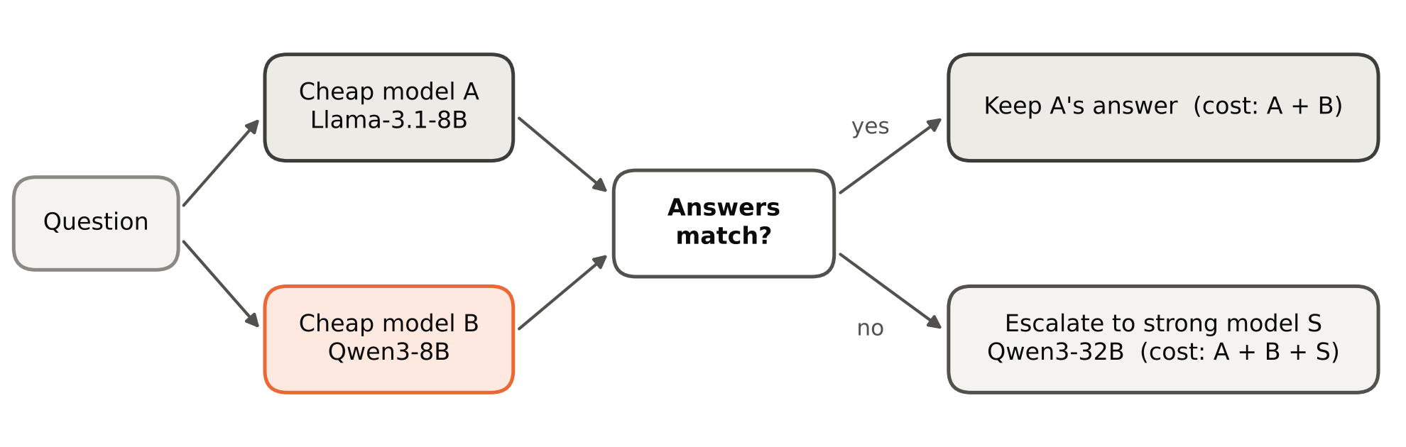
Figure 1. The disagreement router. Two cheap models, Llama-3.1-8B (anchor A) and Qwen3-8B (partner B), answered every question. When their answers matched, the anchor's answer was returned at the cost of A plus B; otherwise the question was escalated to Qwen3-32B (S) at the cost of A, B and S. Model roles were fixed before any routing result was seen. Each model answered each of the 1,100 questions once with greedy decoding, and routing was simulated on the stored answers.
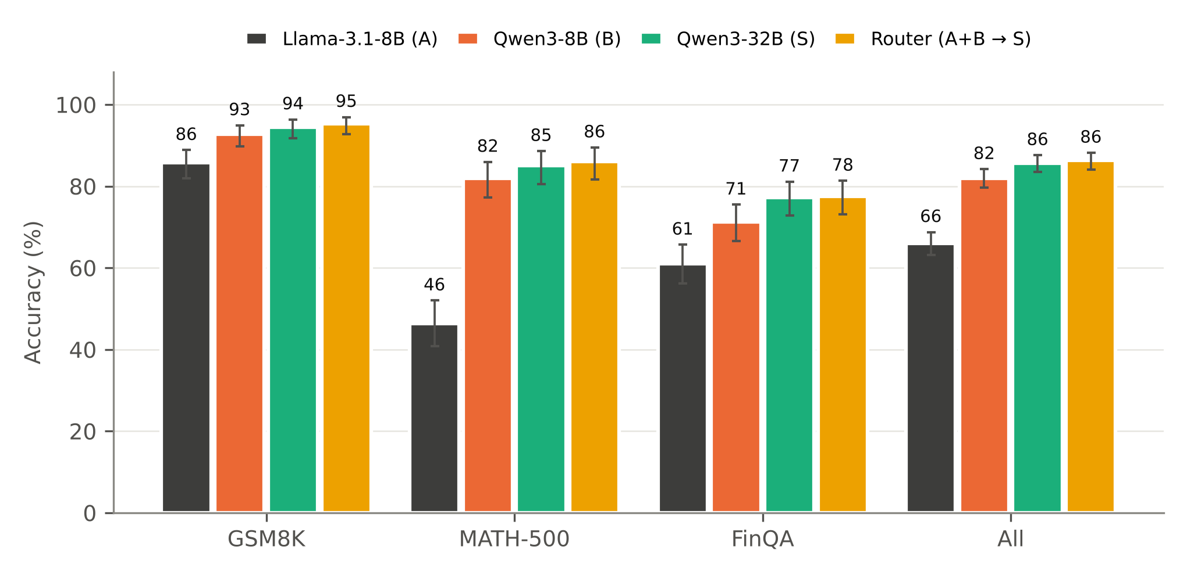
Figure 2. The router matched the strong model's accuracy in every domain. Accuracy of Llama-3.1-8B (A), Qwen3-8B (B), Qwen3-32B (S) and the disagreement router on GSM8K (n = 400), MATH-500 (n = 300), FinQA (n = 400) and all questions (n = 1,100). Error bars show Wilson 95% confidence intervals. Each model answered each question once with greedy decoding. Overall, the router was 0.6 points above Qwen3-32B (paired bootstrap 95% CI −0.3 to 1.5, 2,000 resamples).
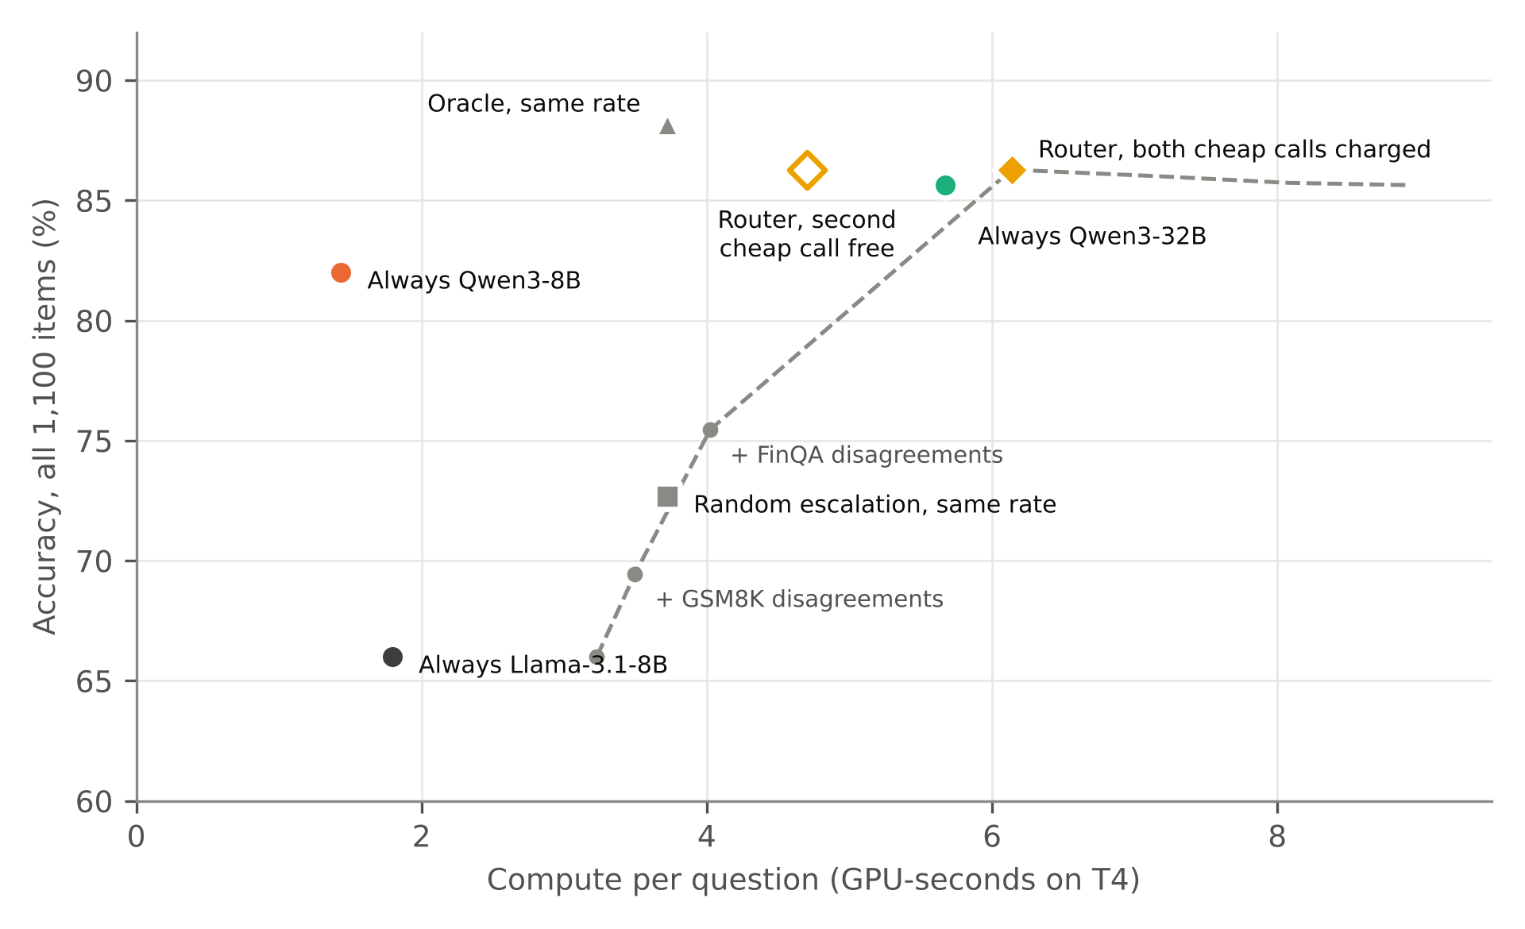
Figure 3. Cost and accuracy of each routing policy. Mean compute per question (GPU-seconds on NVIDIA T4) against accuracy on all 1,100 questions. Random and oracle escalation were charged the anchor plus escalations at the router's escalation rate. The open diamond is the router when the second cheap model is already running. The dashed line adds groups of questions in order of their price per extra correct answer (Table 3); its last segments escalate agreed questions and lower accuracy. Compute comes from one run of each model, apportioned to questions by output tokens.
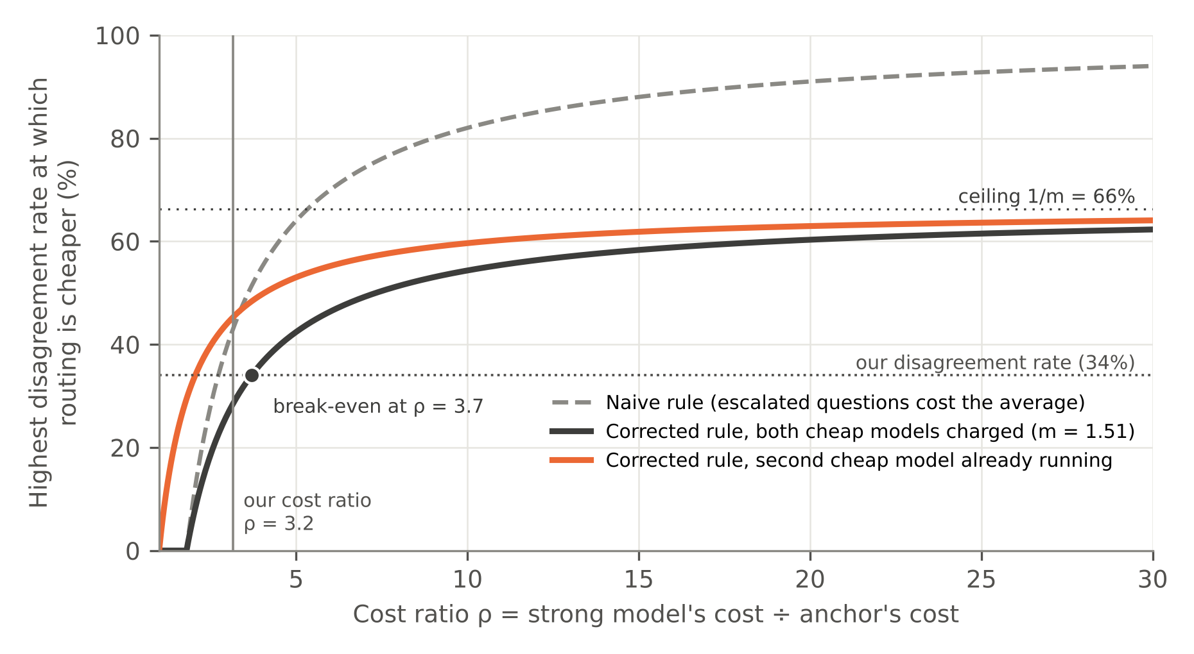
Figure 4. The corrected break-even rule limits when routing can save compute. Highest disagreement rate at which routing uses less compute than always calling the strong model, as a function of the cost ratio ρ (strong model's cost divided by the anchor's). The naive rule (Proposition 1) assumes escalated questions cost the strong model its average; the corrected rule (Proposition 1′) uses the measured m = 1.51 and β = 0.80, with both cheap models charged or with the second cheap model already running. Dotted lines mark the observed disagreement rate (34%) and the ceiling 1/m (66%); the vertical line marks the measured ρ = 3.2.
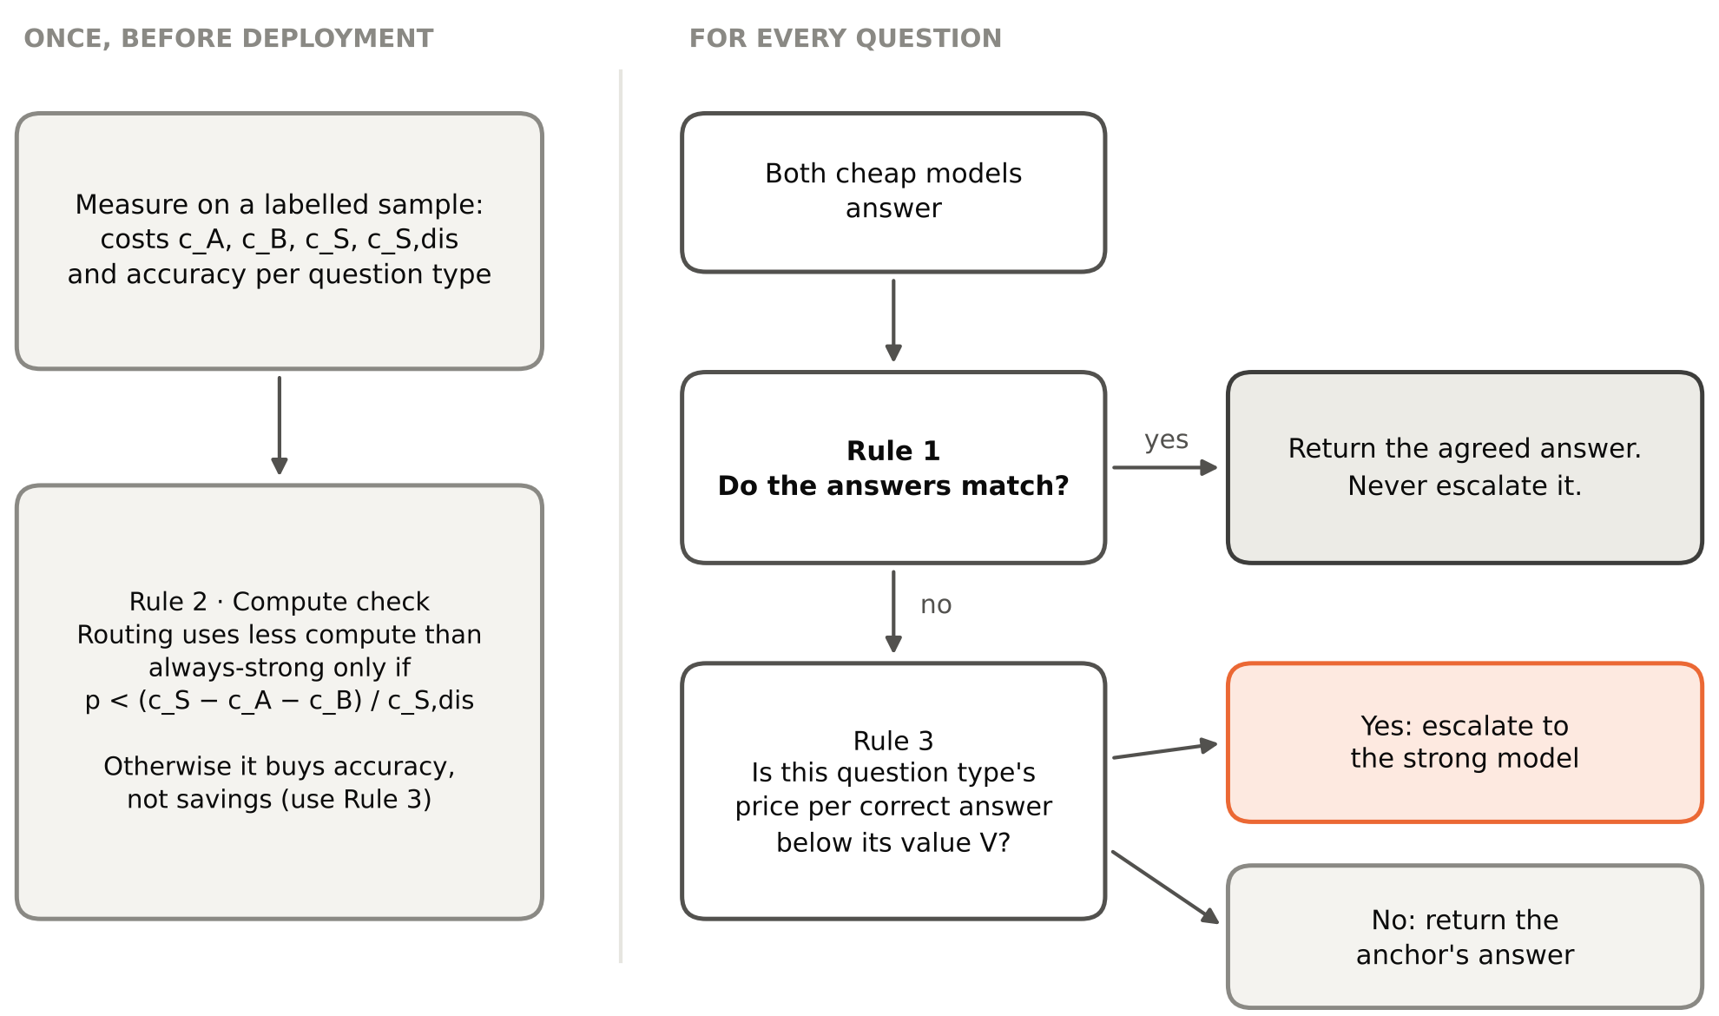
Figure 5. Deciding when and how much to escalate. Once before deployment, per-model costs and per-question-type accuracies are measured on a labelled sample and Proposition 1′ is checked (Rule 2). For every question, agreed answers are returned without escalation (Rule 1), and a disagreement is escalated only if the price per extra correct answer for its question type is below the value V of a correct answer (Rule 3). Thresholds in the text come from the 1,100-question evaluation.

TABLES WITH CAPTIONS
Domain | Disagree | Acc(A) | agree | Acc(A) | disagree | Gap, points | AUROC | Errors caught | Alarms that were real | η
GSM8K | 16% | 98.2% | 21.5% | 76.7  [67.1, 86.9] | 0.93  [0.88, 0.96] | 89% | 78% | 0.82
MATH-500 | 52% | 94.4% | 2.5% | 91.9  [86.7, 96.0] | 0.96  [0.94, 0.98] | 95% | 97% | 0.97
FinQA | 38% | 85.9% | 20.4% | 65.5  [57.6, 73.0] | 0.82  [0.79, 0.86] | 78% | 80% | 0.77
All | 34% | 93.3% | 13.1% | 80.1  [76.1, 84.0] | 0.90  [0.88, 0.92] | 87% | 87% | 0.88
Table 1. Cross-model disagreement was a reliable alarm for anchor errors. Llama-3.1-8B was the anchor and Qwen3-8B the partner. Disagree, share of questions on which the two models disagreed; Acc(A) | agree and Acc(A) | disagree, anchor accuracy when the pair agreed and when it disagreed; Gap, difference between them in percentage points; AUROC, area under the receiver operating characteristic curve for disagreement as a detector of anchor errors; Errors caught, share of the anchor's errors that were escalated; Alarms that were real, share of escalations in which the anchor was wrong; η, routing efficiency (0, random escalation; 1, oracle). Brackets give bootstrap 95% confidence intervals (1,000 resamples). n = 400 (GSM8K), 300 (MATH-500), 400 (FinQA) and 1,100 (All) questions, one answer per model.
Domain | p | Break-even, Prop. 1 | Break-even, Prop. 1′ | Prop. 1′, second model free | GPU-s: router / strong | Cheaper (both charged) | Cheaper (second free)
GSM8K | 16% | 44% | 35% | 55% | 2.74 / 3.60 | Router | Router
MATH-500 | 52% | 48% | 36% | 56% | 13.50 / 11.05 | Always-strong | Router
FinQA | 38% | 31% | 30% | 52% | 4.02 / 3.71 | Always-strong | Router
All | 34% | 43% | 29% | 45% | 6.14 / 5.67 | Always-strong | Router
Table 2. The corrected break-even rule identified the cheaper policy in every domain. p, observed disagreement rate; Prop. 1, pre-registered break-even disagreement rate, which assumes escalated questions cost the strong model its average; Prop. 1′, corrected break-even rate using the strong model's cost on escalated questions, with both cheap models charged or with the second cheap model already running; GPU-s, mean GPU-seconds per question for the router with both cheap models charged and for always calling the strong model. Routing is cheaper when p is below the break-even rate. Costs come from one run of each model on two NVIDIA T4 GPUs; n as in Table 1.
Group of questions | Questions | Correct answers gained | Price per extra correct answer | In dollars | Escalated so far
GSM8K, disagree | 65 | +38 | 7.75 GPU-s | $0.0005–$0.0011 | 6%
FinQA, disagree | 152 | +66 | 8.79 GPU-s | $0.0006–$0.0013 | 20%
MATH-500, disagree | 157 | +119 | 19.54 GPU-s | $0.0014–$0.0029 | 34%
GSM8K, agree | 335 | −3 | never (accuracy falls) | — | —
MATH-500, agree | 143 | −3 | never (accuracy falls) | — | —
FinQA, agree | 248 | −1 | never (accuracy falls) | — | —
Table 3. Escalating groups of questions in order of their price per extra correct answer. Groups combine domain and agreement state and are ordered by marginal cost per correct answer (MCCA, Proposition 2) relative to always using the anchor. Correct answers gained, net change in correct answers when the group is escalated to Qwen3-32B; In dollars, price at $0.25–$0.53 per T4-hour; Escalated so far, cumulative share of all 1,100 questions escalated. Escalating agreed groups lowered accuracy, so they have no price. Switching every question from Llama-3.1-8B to Qwen3-32B costs 19.73 GPU-seconds per extra correct answer.

APPENDIX
The main text is limited to eight figures and tables. The appendices below hold reference material and supplementary results that could not be placed in the main text within that limit; each section states why it is included. Appendix G contains code and needs no justification.
Appendix A. Glossary
Reason for inclusion: the study combines terms from machine learning, cost accounting and statistics, and readers outside the field need one place where each symbol is defined.
Term | Meaning
Anchor (A) | The cheap model whose answer is kept when the two cheap models agree (Llama-3.1-8B).
Partner (B) | The second cheap model whose answer is compared with the anchor's (Qwen3-8B).
Strong model (S) | The expensive model that answers escalated questions (Qwen3-32B).
Escalation | Sending a question to the strong model because the cheap models disagree.
Disagreement rate p | Share of questions on which the two cheap models give different answers.
GPU-second | One second of one GPU's time; the cost unit of this study.
Cost ratio ρ | Strong model's average cost divided by the anchor's.
m | How much more the strong model costs on escalated questions than on average (here 1.51).
Honest accounting | Charging both cheap models on every question.
η (routing efficiency) | Share of the possible gain over random escalation that the router captures; 1 is perfect.
MCCA | Marginal cost per correct answer: compute spent per extra correct answer from escalating a group.
V | What one extra correct answer is worth to the user, in the same units as cost.
AUROC | Area under the receiver operating characteristic curve: how well disagreement separates the anchor's right and wrong answers; 0.5 is chance, 1 is perfect.
φ, κ | Correlation between the two cheap models' errors; chance that their wrong answers coincide.
False accept / false alarm | The pair agrees on a wrong answer / disagrees although the anchor was right.
AWQ, vLLM | A 4-bit weight compression method; the serving software used to run the models.
Table A1. Terms and symbols. Definitions used throughout the manuscript.
Appendix B. Supplementary results
Reason for inclusion: these tables give the complete numbers behind statements in Results (confidence intervals for every model, costs per million questions, the Lemma 1 check and the prompt revision); they are moved here only to respect the limit of eight figures and tables.
Policy | GSM8K | MATH-500 | FinQA | All
Llama-3.1-8B (A) | 85.8%  [82.0, 88.8] | 46.3%  [40.8, 52.0] | 61.0%  [56.1, 65.7] | 66.0%  [63.1, 68.7]
Qwen3-8B (B) | 92.8%  [89.8, 94.9] | 82.0%  [77.3, 85.9] | 71.3%  [66.6, 75.5] | 82.0%  [79.6, 84.2]
Qwen3-32B (S) | 94.5%  [91.8, 96.3] | 85.0%  [80.5, 88.6] | 77.3%  [72.9, 81.1] | 85.6%  [83.4, 87.6]
Router (A + B → S) | 95.3% | 86.0% | 77.5% | 86.3%
Table B1. Accuracy by policy and domain. Wilson 95% confidence intervals in brackets; n = 400 (GSM8K), 300 (MATH-500), 400 (FinQA) and 1,100 (All).
Policy (per 1 million questions) | Accuracy | GPU-hours | Rental cost | Energy, kWh (max) | Wrong answers
Always Llama-3.1-8B | 66.0% | 498 | $125–$264 | 35 | 340,000
Always Qwen3-8B | 82.0% | 399 | $100–$211 | 28 | 180,000
Always Qwen3-32B | 85.6% | 1,575 | $394–$835 | 110 | 143,636
Router, both cheap models charged | 86.3% | 1,705 | $426–$904 | 119 | 137,273
Router, second cheap model already running | 86.3% | 1,306 | $327–$692 | 91 | 137,273
Table B2. Measured compute scaled to one million questions. Rental cost at $0.25–$0.53 per T4-hour; energy is an upper bound at the T4's 70 W board limit and covers GPUs only.
Comparison (per 1 million questions) | GPU-hours | Money | Fewer wrong answers | Price per avoided error
Router (second model running) vs always Qwen3-32B | saves 268 | saves $67–$142 | 6,364 | free (and cheaper)
Router (both charged) vs always Qwen3-32B | costs 130 | costs $33–$69 | 6,364 | $0.0051–$0.0108
Router (second model running) vs always Qwen3-8B | costs 908 | costs $227–$481 | 42,727 | $0.0053–$0.0113
Router (both charged) vs always Qwen3-8B | costs 1,306 | costs $327–$692 | 42,727 | $0.0076–$0.0162
Always Qwen3-32B vs always Qwen3-8B | costs 1,176 | costs $294–$623 | 36,364 | $0.0081–$0.0171
Table B3. What each choice spends and saves. The router's accuracy edge over Qwen3-32B (6,364 fewer errors per million) is within statistical noise.
Domain | Error correlation φ | Collision κ | False accept, measured / predicted | False alarm, measured / predicted | η
GSM8K | 0.30 | 0.40 | 1.5% / 1.5% | 3.5% / 3.5% | 0.82
MATH-500 | 0.37 | 0.16 | 2.7% / 2.7% | 1.3% / 1.3% | 0.97
FinQA | 0.48 | 0.40 | 8.8% / 8.8% | 7.8% / 7.0% | 0.77
Llama + Mistral-7B, GSM8K (prompt v1) | 0.13 | 0.10 | 1.3% / 1.3% | 59.5% / 59.5% | —
Table B4. Lemma 1 check. Measured failure rates against the rates predicted from φ, κ and the models' error rates, as shares of questions.
Prompt v1 → v2 | GSM8K | MATH-500 | FinQA | All
Llama-3.1-8B accuracy | 86% → 86% | 45% → 46% | 58% → 61% | 64% → 66%
Qwen3-8B accuracy | 92% → 93% | 73% → 82% | 27% → 71% | 63% → 82%
Disagreement rate (strict rule) | 16% → 17% | 54% → 53% | 82% → 43% | 50% → 36%
Table B5. Effect of the prompt revision. Prompt v1 asked for “no commas”; Qwen3-8B then wrote 22.97 as 2297 on 178 of 400 FinQA questions. Prompt v2 adds “keep the decimal point” with examples.
Appendix C. Prompts
Reason for inclusion: the exact wording is needed to replicate the study and is too long for Materials and Methods.
Prompt v1 (diagnostic runs only):
You are a careful quantitative reasoner. Solve the problem step by step, briefly.
Then write the final answer on its own last line in exactly this form:
ANSWER: <number>
The number must be plain: no units, no currency symbols, no percent signs, no commas.

Prompt v2 (all main results):
You are a careful quantitative reasoner. Solve the problem step by step, briefly.
Then write the final answer on its own last line in exactly this form:
ANSWER: <number>
Write the number as a plain decimal and keep the decimal point, for example
ANSWER: 22.97 or ANSWER: -5781 or ANSWER: 0.31. Do not include units, currency
symbols, percent signs or thousands separators.

Qwen models received chat_template_kwargs = {"enable_thinking": false}; for Mistral the instruction was placed in the user turn. On the first 60 FinQA questions Qwen3-8B scored 14/60 under v1 and 44/60 under v2.
Appendix D. Compute environment and hardware decisions
Reason for inclusion: the environment determines the cost figures, and the hardware choice explains why every model was run under one runtime; these details are too long for Materials and Methods.
Component | Value
Platform | Kaggle Notebooks, free tier (requires phone verification for GPU and internet)
GPU | 2 × NVIDIA Tesla T4, 15,360 MiB each, compute capability 7.5; no BF16 support
Quota | 30 GPU-hours per week (shown in session options); 12-hour sessions
Software | Driver 580.178.04, CUDA 13.0; Python 3.13; PyTorch 2.13.0+cu130; vLLM 0.32.0
Serving | OpenAI-compatible server; maximum context 8,192; GPU memory utilisation 0.90; 32 concurrent requests
Run times (prompt v2) | Llama-3.1-8B 33 min, Qwen3-8B 26 min (one GPU each); Qwen3-32B 52 min (two GPUs)
Table D1. Environment as recorded in the notebook. Values copied from the Kaggle session and server logs.
Option considered | Key facts | Decision
MacBook Pro M4 Max, 48 GB (local) | 546 GB/s memory bandwidth; fits the 32B model; serves about one request at a time (estimated 4–5 h for the 32B run) | Not used: a different runtime and compression would make costs incomparable unless every model ran there
MacBook Air M4, 16–32 GB (local) | 120 GB/s, fanless; 32B fits only in the 32 GB model; estimated 80–100 h in total | Rejected
Rented GPU (e.g. L40S, about $0.79/h) | Fastest; estimated under $10 for the whole study | Not needed
Free APIs (OpenRouter, Groq) | OpenRouter free models: 50 requests/day without purchased credits; Groq: per-model daily token caps; no control over quantisation or version | Rejected: too slow, not reproducible
Kaggle free tier, 2 × T4 | 30 GPU-h/week; all models under one runtime | Chosen
Table D2. Hardware options. Estimates are rough; speeds on Apple silicon depend on the runtime.
During the 32B run, CPU use reached 300% of 4 cores because T4s cannot exchange data directly and the CPU relays it between them; both GPUs ran at 100% with 14 GB in use each. The 8B models fit on one T4, so the second GPU was idle during those runs and their cost counts one GPU.
Appendix E. Experimental log
Reason for inclusion: every problem met during the study is recorded so that others can reproduce the set-up and judge which decisions were made after seeing data; a 23-row table cannot fit in the main text.
# | Problem | Cause | Resolution | Effect
1 | Planned hardware unsuitable | Study designed for an M4 Max; a MacBook Air M4 was considered | Moved to Kaggle (2 × T4) | Cost in GPU-seconds
2 | No GPU option in a new notebook | Kaggle unlocks GPUs only after phone verification | Verified phone; GPU T4 × 2, internet on | None
3 | Long list of pip dependency errors | vLLM upgraded PyTorch/CUDA; unused preinstalled packages conflict | Ignored; GPUs verified with a test matrix multiply | None
4 | Hugging Face token not picked up | Secret named “api key”; libraries read only HF_TOKEN | Loaded the secret into HF_TOKEN | None
5 | kaggle-vllm helper refused to install | Expects Python 3.12 / PyTorch 2.10 | Not needed; upstream vLLM worked | None
6 | “Background processes not supported” | Kaggle blocks shell jobs started with “&” | Server started with subprocess.Popen | None
7 | Server crashed on start | torchaudio built for CUDA 12.8, PyTorch on CUDA 13.0 | Uninstalled torchaudio | None
8 | Server killed while loading | A cell's stop button sends SIGINT to child processes | Server started in its own session | One lost warm-up
9 | “Cannot use FA version 2” | FlashAttention 2 needs a newer GPU | None; vLLM falls back | None
10 | Run cell looked unresponsive | Cell only defines a function | Ran with Shift + Enter | None
11 | “Unauthenticated requests” warning | Kernel restart cleared the token | Token cell re-run after restarts | None
12 | Gemma-2-9B crashed on start | Refuses FP16; T4s lack BF16; FP32 would not fit | Gemma dropped | Line-up changed
13 | Mistral-7B scored 25.8% | Answered before reasoning on 52% of replies | Kept as weak-partner case only | Partner changed
14 | Partner and strong model share a family | Qwen3-8B chosen after Mistral failed | Accepted; anchor cross-family to both | Limitation
15 | Qwen3-8B at 27% on FinQA | “No commas” made it drop the decimal point | Prompt v2; all models re-run | FinQA 27% → 71%
16 | Lemma 1 failed on FinQA (v1) | ×100 rescue let 2297 “agree” with 22.97 (100 items) | Fixed at source by prompt v2 | See 22
17 | Truncated replies scored as correct | Fallback read numbers from cut-off replies | Fallback disabled for truncated replies | Small accuracy drop
18 | Throughput fell from about 360 to 180 tokens/s | FinQA prompts carry long tables | None; not throttling | Cost apportioned per item
19 | Second GPU idle in 8B runs | 8B models fit on one T4 | Charged 1 GPU (cheap) and 2 (strong) | Fair accounting
20 | Risk of crash when splitting the 32B model | T4s relay data through the CPU | Ran in 52 min without error | None
21 | Stale files in the backup archive | zip never removes old entries | Verified identical to v1 copies; excluded | None
22 | Which agreement rule is primary | Strict rule proposed after v1; worse under v2 (20 vs 3 inconsistencies) | Pre-registered rule kept; strict reported | Nearly identical results
23 | Pre-registered break-even prediction failed | Escalated questions cost about twice the average | Proposition 1′ derived | New finding
Table E1. Every problem met during the study, in order (19–20 October 2026). An earlier draft also misattributed arXiv:2410.10347, which is by Dekoninck, Baader and Vechev.
Appendix F. Prompt-v1 diagnostics
Reason for inclusion: these runs show how a weak partner and a formatting artefact distort the signal (Results, RQ3 and Robustness); they used the superseded prompt and so do not belong among the main figures.
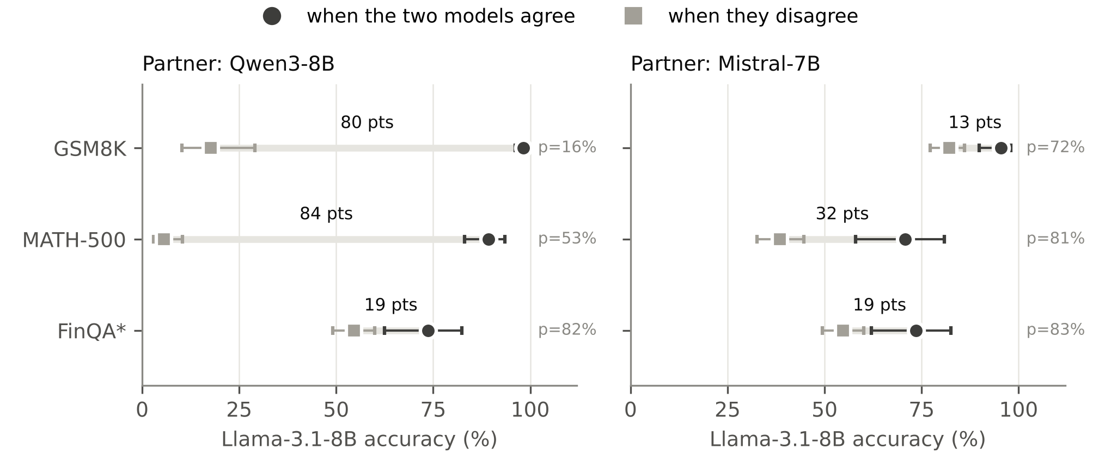
Figure F1. Anchor accuracy under prompt v1. Llama-3.1-8B accuracy when it agreed or disagreed with Qwen3-8B (left) and with the weak partner Mistral-7B (right), with Wilson 95% confidence intervals; p is the disagreement rate. FinQA, marked with an asterisk, uses the strict agreement rule because of the decimal artefact.
Mistral-7B answering without reasoning. Two examples of the 571 replies that began with “ANSWER”:
gsm8k-0179. If Sam and Harry have 100 feet of fence between them, and they agree to split it with Harry getting 60 feet more than Sam, how much is left over for Sam?
Reply: ANSWER: 40
Gold answer: 20

gsm8k-0369. Wendy wants to place 20 more than double the number of books in a shelving system with 6 rows and 6 columns. How many books will she need to carry to complete her task?
Reply: ANSWER: 120
Gold answer: 92

Qwen3-8B dropping the decimal point (prompt v1):
finqa-0006 | gold 0.22972 (23.0%) | extracted 2297
...
$1246 / $5424 = 0.2297
0.2297 * 100 = 22.97
ANSWER: 2297

finqa-0001 | gold 0.0776 (7.8%) | extracted 776
...
\text{ROI} = \left( \frac{107.76 - 100.00}{100.00} \right) \times 100 = 7.76
$$
ANSWER: 776

Appendix G. Notebook code
Starting a model server on Kaggle so that it survives the stop button and receives the Hugging Face token:
server = subprocess.Popen(
["vllm", "serve", model, "--quantization", "awq", "--dtype", "float16",
"--max-model-len", "8192", "--gpu-memory-utilization", "0.90",
"--port", "8000", *extra], # extra = ("--tensor-parallel-size", "2") for 32B
stdout=open("server.log", "w"), stderr=subprocess.STDOUT,
env=os.environ.copy(), start_new_session=True)

Checking accuracy, disagreement and the router from the stored replies:
def ok(a, g): return a is not None and any(abs(a*s - g) <= 0.01*max(1, abs(g)) for s in (1, 100, 0.01))
P = {m: load(m) for m in ["llama8", "qwen8b", "qwen32b"]} # load() applies the extractor
for task in ["gsm8k", "math500", "finqa", None]:
ids = [i for i in gold if task is None or gold[i]["task"] == task]
agree = {i: P["qwen8b"][i] is not None and ok(P["llama8"][i], P["qwen8b"][i]) for i in ids}
router = sum(ok(P["llama8" if agree[i] else "qwen32b"][i], gold[i]["gold"]) for i in ids) / len(ids)

Steven Kolawole et al., “Agreement-Based Cascading for Efficient Inference,” Transactions on Machine Learning Research (2025), https://doi.org/10.48550/arXiv.2407.02348.
Duncan Soiffer et al., “Semantic Agreement Enables Efficient Open-Ended LLM Cascades,” in Proceedings of the 2025 Conference on Empirical Methods in Natural Language Processing: Industry Track (Suzhou: Association for Computational Linguistics, 2025), 2499–2537, https://doi.org/10.18653/v1/2025.emnlp-industry.171.
Murong Yue et al., “Large Language Model Cascades with Mixture of Thought Representations for Cost-Efficient Reasoning,” in International Conference on Learning Representations (ICLR 2024), https://doi.org/10.48550/arXiv.2310.03094.
Lingjiao Chen et al., “FrugalGPT: How to Use Large Language Models While Reducing Cost and Improving Performance,” Transactions on Machine Learning Research (2024), https://openreview.net/forum?id=cSimKw5p6R.
Pranjal Aggarwal et al., “AutoMix: Automatically Mixing Language Models,” in Advances in Neural Information Processing Systems 37 (NeurIPS 2024), https://doi.org/10.48550/arXiv.2310.12963.
Dujian Ding et al., “Hybrid LLM: Cost-Efficient and Quality-Aware Query Routing,” in International Conference on Learning Representations (ICLR 2024), https://doi.org/10.48550/arXiv.2404.14618.
Isaac Ong et al., “RouteLLM: Learning to Route LLMs from Preference Data,” in International Conference on Learning Representations (ICLR 2025), https://doi.org/10.48550/arXiv.2406.18665.
Jasper Dekoninck et al., “A Unified Approach to Routing and Cascading for LLMs,” in Proceedings of the 42nd International Conference on Machine Learning, PMLR 267 (2025): 12987–13010, https://proceedings.mlr.press/v267/dekoninck25a.html.
Yasmin Moslem and John D. Kelleher, “Dynamic Model Routing and Cascading for Efficient LLM Inference: A Survey,” preprint, arXiv, 2026, https://doi.org/10.48550/arXiv.2603.04445.
Ludmila I. Kuncheva and Christopher J. Whitaker, “Measures of Diversity in Classifier Ensembles and Their Relationship with the Ensemble Accuracy,” Machine Learning 51, no. 2 (2003): 181–207, https://doi.org/10.1023/A:1022859003006.
Soiffer et al., “Semantic Agreement.”
Aaron Grattafiori et al., “The Llama 3 Herd of Models,” preprint, arXiv, 2024, https://doi.org/10.48550/arXiv.2407.21783.
An Yang et al., “Qwen3 Technical Report,” preprint, arXiv, 2025, https://doi.org/10.48550/arXiv.2505.09388.
Karl Cobbe et al., “Training Verifiers to Solve Math Word Problems,” preprint, arXiv, 2021, https://doi.org/10.48550/arXiv.2110.14168.
Dan Hendrycks et al., “Measuring Mathematical Problem Solving with the MATH Dataset,” in Proceedings of the Neural Information Processing Systems Track on Datasets and Benchmarks (2021), https://doi.org/10.48550/arXiv.2103.03874; Hunter Lightman et al., “Let's Verify Step by Step,” in International Conference on Learning Representations (ICLR 2024), https://doi.org/10.48550/arXiv.2305.20050.
Zhiyu Chen et al., “FinQA: A Dataset of Numerical Reasoning over Financial Data,” in Proceedings of the 2021 Conference on Empirical Methods in Natural Language Processing (Online and Punta Cana: Association for Computational Linguistics, 2021), 3697–3711, https://doi.org/10.18653/v1/2021.emnlp-main.300.
Woosuk Kwon et al., “Efficient Memory Management for Large Language Model Serving with PagedAttention,” in Proceedings of the Symposium on Operating Systems Principles (SOSP ’23) (Koblenz: ACM, 2023), 611–626, https://doi.org/10.1145/3600006.3613165.
Ji Lin et al., “AWQ: Activation-Aware Weight Quantization for On-Device LLM Compression and Acceleration,” Proceedings of Machine Learning and Systems 6 (2024): 87–100, https://doi.org/10.48550/arXiv.2306.00978.
“NVIDIA Tesla T4 Cloud Pricing: Where to Rent & How Much It Costs,” Deploybase, accessed 29 October 2026, https://deploybase.ai/articles/tesla-t4-price; Carl Peterson, “NVIDIA Tesla T4 Pricing (October 2026): Is It Still Worth It?,” Thunder Compute, accessed 29 October 2026, https://www.thundercompute.com/blog/nvidia-t4-pricing.

